Solutions to Accompany

Information Technology

Project Management,

Third Edition

ISBN 0-619-159847

Course Technology MIS Series

Companion Web Site: www.course.com/mis/schwalbe

Kathy Schwalbe, Ph.D., PMP

Table of Contents

CHAPTER 1 1
CHAPTER 2 3
CHAPTER 3 7
CHAPTER 4 9
CHAPTER 5 13
CHAPTER 6 18
CHAPTER 7 22
CHAPTER 8 27
CHAPTER 9 31
CHAPTER 10 35
CHAPTER 11 38
CHAPTER 12 41
APPENDIX A 44
APPENDIX B 49
APPENDIX C 51

List of solution files available with the Instructor Resource material:
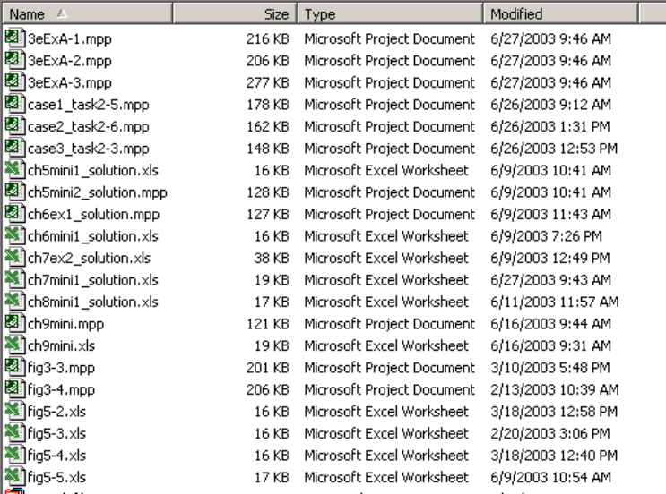

CHAPTER 1
Introduction to Project Management

Discussion Questions
- Why is there a new or renewed interest in the field of project management?
More and more projects are being done by a variety of organizations. The projects are more complex and often involve the use of new technologies. Organizations are struggling to find better ways to manage their projects.
- What is a project? How is it different from what most people do in their day-to-day jobs?
A project is “a temporary endeavor undertaken to create a unique product or service” (PMBOK® Guide, 2000, p. 4). Projects are different from day-to-day activities primarily because they have focused goals and definite beginning and ending dates.
- What is project management? Briefly describe the project management framework.
Project management is “the application of knowledge, skills, tools, and techniques to project activities in order to meet project requirements” (PMBOK® Guide, 2000, p. 6). The project management framework graphically shows the process of beginning with stakeholders’ needs and expectations, applying the nine project management knowledge areas and various tools and techniques to lead to project success and then enterprise success.
- How does project management relate to other disciplines?
Project management is a separate discipline, but it does overlap with general management and the application area of the project.
- Briefly describe some key events in the history of project management. What project was the first to use “modern” project management?
Some people say that building the Egyptian pyramids or the Great Wall of China were projects. Modern project management began with the Manhattan Project or development of the atomic bomb, which took about three years and cost almost $2 billion in 1946. This project had a separate project manager and technical manager.
- What is the career outlook for project managers in information technology? Describe recent trends in project management certification and software tools.
The demand for project managers continues to grow as more organizations take on projects. PMP certification continues to grown, and people are also starting to earn IT Project+ certification from CompTIA.

Exercises
Answers to all of these exercises will vary. The main purpose of these exercises is to have students begin doing some independent research to further explore the field of project management. You could have students discuss the results of these exercises in class to enhance participation. The exercises are provided here for your convenience.
- Visit the Standish Group’s Web site (www.standishgroup.com). Read one of the CHAOS articles or a similar report on information technology project management on their site or a similar site. Write a one-page summary of the report, its key conclusions, and your opinion of the report.
Answers will vary.
- Find someone who works as a project manager or is a member of a project team. Prepare several interview questions, and then ask that person your questions in person, via the phone, or via the Internet. Write a one- to two-page summary of your findings.
- Search the Internet for the terms project management, project management careers, project portfolio management, and information technology project management. Write down the number of hits that you received for each of these phrases. Find at least three Web sites that provide interesting information on one of the topics. In a one- to two-page paper, summarize key information about these three Web sites, as well as the Project Management Institute’s Web site (www.pmi.org).
- Scan information technology industry journals or Web sites such as Information Week, Computer World, and Information World, and find one good article about information technology project management. Write a one- to two-page paper describing the article.
- Skim through Appendix A on Microsoft Project 2002. Review information about Project 2002 from Microsoft’s Web site (www.microsoft.com/project). Write a one- to two-page paper answering the following questions:
  - What functions does this software provide that cannot be done easily using other tools such as a spreadsheet or database?
  - Does the software appear easy to learn?
  - What are key inputs and outputs of the software?
  - What is the main difference between the enterprise version of Microsoft Project 2002 and Project Standard 2002?

CHAPTER 2

The Project Management and Information Technology Context

Discussion Questions
- What does it mean to take a systems view of a project? How does taking a systems view of a project apply to project management?
Taking a systems view means looking at the big picture of how a particular project fits into the rest of the organization. It is important for project managers to understand the broader organizational environment to ensure their projects meet organizational needs.
- Explain the four frames of organizations. How can they help project managers understand the organizational context for their projects?
The four frames of organizations are summarized below:
- Structural: deal with how the organization is structures and focus on roles and responsibilities. It’s important to understand these roles and responsibilities when dealing with project stakeholders, especially in procuring resources.
- Human resources: focuses on meeting the needs of the organization and its people. Project managers must understand various human resources policies and procedures.
- Political: addresses organizational and personal politics. Many project managers fail because they do not understand the political environment.
- Symbolic: focuses on symbols and meanings. It’s important to understand an organization’s culture, dress code, work ethic, and so on in managing projects.
- Briefly explain the differences between functional, matrix, and project organizations. Describe how each structure affects the management of the project.
Functional organizations have managers or vice presidents in specialties such as engineering, manufacturing, information technology, and so on. Their staffs have specialized skills in their respective disciplines. Project organizations have project managers instead of functional managers reporting to the CEO. Matrix organizations represent the middle ground between functional and project structures. Personnel often report to both a functional manager and one or more project managers. Project managers have the most authority in project organizational structures followed by matrix, and then functional.
- Discuss the importance of top management commitment and the development of standards for successful project management. Provide examples to illustrate the importance of these items based on your experience on any type of project.
Top management commitment is the number one factor associated with the success of information technology projects, so it’s very important to get and maintain this support. Top management can help project managers get adequate resources, approve unique project needs, help get cooperation from other parts of the organization, and provide support as a mentor and coach to project managers. Examples will vary.
- How does a project life cycle differ from a product life cycle? Why does a project manager need to understand both?
A project life cycle is a collection of project phases⎯concept, development, implementation, and close-out. These phases do not vary by project. Product life cycles vary tremendously based on the nature of the project. For example, the Systems Development Life Cycle (SDLC) could follow the waterfall model, spiral model, incremental release model, prototyping model, RAD model, extreme programming model, or scrum model. Using the general phases of the SDLC (information systems planning, analysis, design, implementation, and support) there could be a project to develop a strategic information systems plan; another project to complete a systems analysis for a new system; another project to create a detailed database design; another to install new hardware or software; and another to provide new user training.
- Which skills do you think are most important for an information technology project manager? Can a project manager learn all of these skills, or are some innate?
Answers will vary.
- Do you think project managers of large information technology projects need strong technical skills? Why or why not? What about project managers for small information technology projects?
Project managers leading any type of information technology project should have some technical skills, but generally they need technical skills for larger projects since they will have strong technical people doing those specific tasks. On a smaller project, the project manager may need to do some of the technical work in addition to leading the project team.

EXERCISES
Answers to all of these exercises will vary. They are provided here for your convenience.
- Apply the information on the four frames of organizations to an information technology project with which you are familiar. If you cannot think of a good information technology project, use your personal experience in deciding where to attend college to apply this framework. Write a one- to two-page paper describing key issues related to the structural, human resources, political, and symbolic frames. Which frame seemed to be the most important and why? For example, did you decide where to attend college primarily because of the curriculum and structure of the program? Did you follow your friends? Did your parents have a lot of influence in your decision? Did you like the culture of the campus?
- Read one of the suggested readings by Desaulniers and Anderson, McConnell, and/or Thomsett or search the Internet for an interesting article about software development life cycles, including agile software development. Also, find two informative Web sites related to this subject. What do these sources say about project management? Write a one- to two-page summary of your findings.
- Read one of the suggested readings by Crawford, NWCET, or Posner about project management skills or find another reference about the skills required for a good project manager. Write a one- to two-page paper describing the article and your opinion of the skills it suggests are important.
- Search the Internet and scan information technology industry magazines or Web sites to find an example of an information technology project that had problems. Write a one- to two-page paper summarizing who the key stakeholders were for the project and how they influenced the outcome.
- Write a one- to two-page summary of an article about the importance of top management support for project success.

MINICASE
You have been part of your company’s Information Technology Department for three years. You have learned a lot about the company and about many new technologies in your latest assignment—developing applications for your corporate intranet. Since you are an avid recreational athlete, you have spent a fair amount of time thinking about how you would write a sophisticated application to help people learn about the many corporate athletic teams, register on the intranet, determine team schedules, post team statistics, and so on. You have heard some rumors about profits not being as high as expected in the past year, and you know that mostly the junior employees participate on the athletic teams.
Part 1. Using Figure 2-1 as a guide, use the three-sphere model of systems management to identify potential issues that could be factors in deciding whether you should proceed with your idea to develop an application for recreational athletics at your company. Include at least three questions for each sphere.
Part 2: Your immediate supervisor likes your idea of developing a recreational sports application on the intranet, but he has to convince his supervisor that this project is valuable to the company. Prepare a short presentation with five to ten slides and speaker notes to convince top management to approve the recreational athletics application project. Be sure to list benefits of the project and suggest a phased approach. For example, the first phase might involve just posting information about various sports teams on the intranet. The second phase might include on-line registration, and so on.

SOLUTION: Answers will vary. Be sure students understand the difference between business, organizational, and technical issues for Part 2. For Part 2, be sure students can put together and give a convincing presentation to help sell the project. Below is one possible answer.

Part 1.
Business:
How much time is required to develop the site?
Will additional funds be needed for hardware or software?
Will the site help in finding or retaining employees?
Will the site help promote wellness at the company and reduce insurance costs?

Organizational:
Who will be the main sponsor for the site?
Who will provide inputs for the site?
Who will promote the site?
Who will provide training for the new application?
Will people participate in more sports because of the site?

Technology:
Will the new application be developed using existing hardware, software, and networks?
Will outside resources be needed to help in the site development?
Will new hardware or software be required for servers or client machines?
Will the new application negatively affect the current IT infrastructure?

Part 2.
Slide 1: Title Slide

Slide 2: Concept
- Intranet-based Web Site
- Information on after-hours recreation
  - Company teams and sports
  - How to get involved
  - Scores and statistics
  - Pictures
- Low Cost Way to Improve Employee Health and Morale

Slide 2: Benefits
- Builds Teams
- Promotes Wellness/Better Health/Better Productivity
- Increases Community Name Recognition
- Low Cost or No Cost for Basic System
Slide 3: Phase One
- Static web page
- Activity type, dates, location, contact
- Developed after hours by volunteers or as a class project

Slide 4: Phase Two
- Scores
- Pictures of events
- More information, such as driving directions to games
- One person part-time allocated to develop/maintain site

Slide 5: Phase Two Example
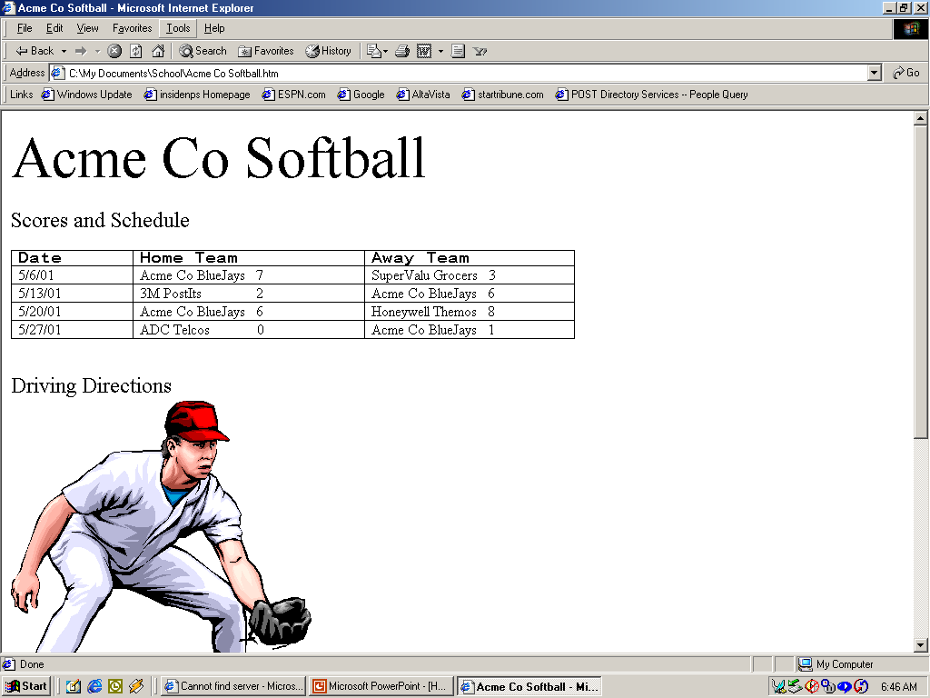
Slide 6: Phase Three
- Statistics
- Online Registration
- More resources required for site development/maintenance
- Potential outside sponsorship

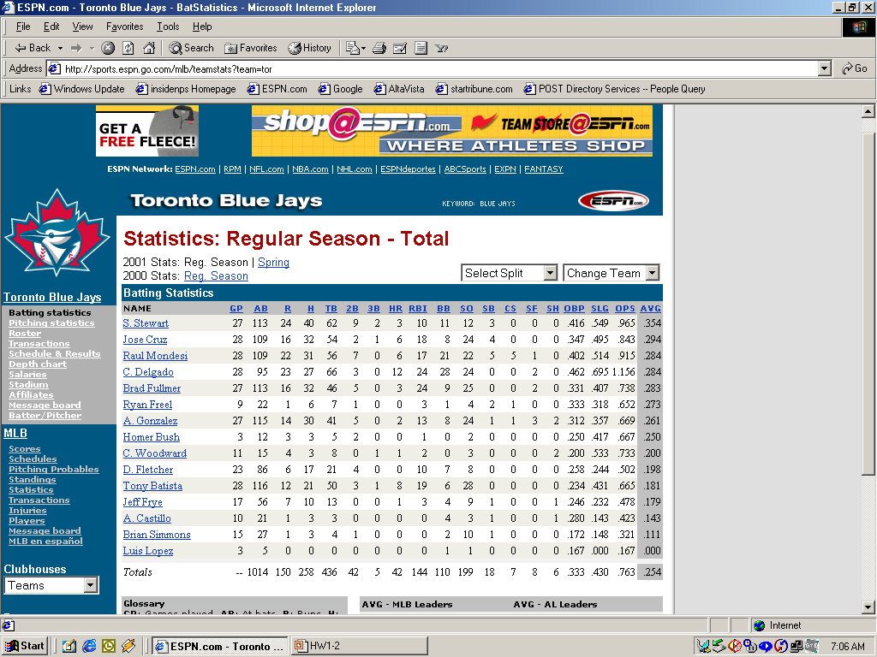
Slide 7: Phase Three Example

CHAPTER 3
The Project Management Process Groups: A Case Study

DISCUSSION QUESTIONS
- Briefly describe what happens in each of the five project management process groups (initiating, planning, executing, controlling, and closing).
Descriptions of what happens in each of the five process groups are listed below:
- Initiating includes actions to commit to begin or end projects and project phases. Some deliverables include defining the business need for the project, getting a project sponsor, and selecting a project manager.
- Planning includes creating workable plans for the entire project. Every knowledge area requires development of some plans.
- Executing involves coordinating everyone and everything to carry out the project plans. Deliverables are the actual work⎯ the products of the project or phase.
- Controlling ensures the project objectives are met. Deliverables include monitoring and measuring progress and taking corrective action.
- Closing involves bringing the project to an orderly end. Deliverables include getting formal acceptance for the project, creating project files, and documenting lessons learned.
- On which process should team members spend the most time? Why?
Generally, the most time on projects should be spent in executing processes. The products of the project are produced during execution, which often takes a lot of time and money.
- What are some of the project management deliverables of each process group?
There are several tables describing outputs of each process groups. Some of the project management deliverables are listed below:
  - Initiating: business case, project charter
  - Planning: team contract, scope statement, WBS, project schedule, list of prioritized risks
  - Executing: change requests, project records, project reports, project presentations
  - Controlling: scope changes, schedule updates, budget updates, change requests
  - Closing: project archives, lessons learned
- What are some of the typical challenges project teams face during each of the five process groups?
Answers will vary, but some suggested as listed below:
  - Initiating: developing a business case, obtaining senior management support, politics
  - Planning: getting knowledgeable people involved, determining project scope, politics
  - Executing: dealing with changes, team motivation, technical skills, senior management support
  - Controlling: dealing with changes, lack of accountability, pressures to meet deadlines and budgets
  - Closing: documentation, prepare a good final report and presentation, transitioning work to other groups, taking time to document lessons learned
- What questions do you have about the sample documents provided?
Answers will vary.

EXERCISES
Answers to all of these exercises will vary. They are provided here for your convenience.
- Study the WBS and Gantt charts provided in Figures 3-3 and 3-4. Enter the WBS into Project 2002, indenting tasks as shown to create the WBS hierarchy. Then enter durations and dependencies to try to reproduce the Gantt chart. Check your work with the files available on the Instructor Resource CD-Rom.
- Read the article by William Munro regarding Blue Cross Blue Shield of Michigan’s information technology project management methodology (available on the companion Web site for this text). Write a one- to two-page summary of the article, its key conclusions, and your opinion of it. Do you think many other organizations could apply this methodology, or does each organization need to create its own methodology?
- Read the “ResNet Case Study” described in the second Suggested Reading (available on the companion Web site for this text). Write a two- to three-page paper summarizing the main outputs produced during each project process group in this case. Also, include your opinion of whether or not Peeter was an effective project manager.
- JWD Consulting wrote a business case during project initiation. Review the contents of this document (Table 3-3) and find another example of a business case for a project. Write a one- to two-page paper comparing the contents of these documents. In addition, describe whether you think all projects should include a business case before the project sponsors officially approve the project.
- Review one of the case studies that IBM provides on its e-business Web site as described in the third suggested reading. Write a one- to two-page paper summarizing the case study and how IBM justified its investment in an information technology project.
- Several organizations prepare a business case and do other work before officially starting projects, sometimes describing these activities as pre-project planning. Find an article that discusses the importance of pre-project planning activities and how they influence project selection and success.

MINICASE
Your supervisor liked your presentation on developing a recreational sports application on your company’s intranet (see the Chapter 2 Minicase). He also showed you a recent report from the Human Resources department showing the relationship between employee health, weight, and activity level and the company’s health insurance costs.
Part 1. Find two articles describing the relationship between employee health and costs to their employers. Try to find specific potential benefits of a corporate-sponsored wellness program. Summarize the findings of these articles in a one- to two-page paper.
Answers will vary.
Part 2: Your company has 20,000 employees, providing health care coverage to all interested workers. The report from the Human Resources department showed that your company is paying 20 percent more than comparable companies do for health benefits, primarily because many employees are overweight or obese based on the body mass index (BMI) scale. Assume that developing the recreational sports application on your intranet and providing a small monetary award for participation and/or weight reduction will bring your health benefits costs to within 10 percent of industry standards. Write a business case for pursuing the recreational sports application, using your imagination and research to fill in the details.

SOLUTION: Answers will vary. Be sure students follow the main assumption of benefits costs being reduced from 20 percent more than average to 10 percent more than average.
CHAPTER 4

Project Integration Management

DISCUSSION QUESTIONS
- Describe project integration management in your own words. How does project integration management relate to the project life cycle, stakeholders, and the other project management knowledge areas?
Project integration management means tying together all of the other aspects involved in a project to make it a success. Integration management relates to the project life cycle in that it is done in all of the project life cycle phases. As the project progresses, integration management becomes more focused. Integration management relates to stakeholders because it requires the project manager to know all of the project stakeholders, to know their interests and concerns about the project, and to manage relationships with them. Integration management pulls together information from all of the other knowledge areas.
- What are some crucial elements of a good project plan? Describe what might be in a project plan for a project to develop a Web-based information system for providing transfer credit information for all colleges and universities in the world.
A good project plan should include the following crucial elements: an introduction or overview of the project, a description of how the project is organized, the management and technical processes used on the project, and sections describing the work to be done, the schedule, and the budget. Answers to the second part of this question will vary. Students should comment that this would be a huge project if it included transfer credit information for all colleges and universities in the world. A good project manager would focus the scope in order to make it more realistic. For example, it might be more feasible to start with all public colleges in a certain state, then expand to include private colleges in that state, and so on.
- What are crucial elements of successful project plan execution? Describe a well-executed project with which you are familiar. Describe a disaster project. What were some of the main differences between these projects?
Crucial elements of successful project plan execution are strong project leadership, communication, and political skills. Product skills and knowledge are also important, as is senior management support. Answers to the rest of the question will vary.
- Discuss the importance of following a well-integrated change control process on information technology projects. What do you think of the suggestions made in this chapter? Think of three additional suggestions for integrated change control on information technology projects.
Answers will vary. One answer might be that it is important to follow a good integrated change control process on information technology projects to avoid scope creep, incompatibility problems, and to make effective use of resources and new technologies. Additional suggestions for managing overall change control might include locating key project stakeholders, assigning users to project teams, and providing team-based incentives for effectively managing project changes.
- Provide an example of how you might use each of the following software tools during project integration management: word processing software, presentation software, spreadsheets, databases, e-mail, the Web, and project management software.
Answers will vary. Word processing software can be used for writing the main text of a project plan. Presentation software would be used for preparing project review information. Spreadsheets could be used to track issues, as could databases. E-mail and the Web could be used to communicate project information. Project management software could be used to enter planned and actual tasks, start and end dates, and resource and other cost information.

EXERCISES
1. Write a one- to two-page paper based on the opening case. Answer the following questions:
a. What do you think the real problem was in this case?
b. Does the case present a realistic scenario? Why or why not?
c. Was Nick Carson a good project manager? Why or why not?
d. What could Nick have done to be a better project manager?
e. What should top management have done to help Nick?
SOLUTION: Answers will vary Make sure students justify their responses. For example, they could say that Nick was a good project manager because he got the job done. They could say he was not a good project manager because he was too technical and did not get along well with senior management.

2. Develop an outline (major headings and subheadings only) for a project plan to create a Web site for your class, and then fill in the details for the introduction or overview section. Assume that this Web site would include a home page with links to a syllabus for the class, lecture notes or other instructional information, links to the Web site for this textbook, links to other Web sites with project management information, and links to personal pages for each member of your class and future classes. Also, include a bulletin board and chat room feature where students and the instructor can exchange information. Assume your instructor is the project’s sponsor, you are the project manager, your classmates are your project team, and you have up to one year to complete the project.
SOLUTION: Answers will vary. A possible project outline might look like this:
- Introduction: The Project Management Class Web Site will enable current and future project management students and faculty to share information related to project management.
- Project Name: Project Management Class Web Site
- Project Description and Need: The growing interest in project management has caused the college to create more courses and offer more sections of project management. By creating a Web site for project management information, faculty and students can create a repository of useful information to enhance teaching and learning. This project will create a Web site for one section of Professor Y's project management course. The project will be completed in one year. Current hardware and software will be used, so we assume there are no additional costs. Students and the instructor will work on the project as part of the class and on a volunteer basis.
- Sponsor: Professor Y, Department Chair or Dean
- Project Manager and Key Team Members: Student Y
- Project Deliverables: A Web site on the college server including a home page with links to Professor Y's class syllabus, lecture notes or other instructional information, links to the Web site for the textbook, links to other Web sites with project management information, and links to personal pages for each member of Professor Y's current class and future classes. There will also be a bulletin board and chat room available from the home page where students and the instructor can exchange information.
- Reference Materials: Current course information and textbook
- Definitions and Acronyms
- Project Organization
- Organization charts
- Project Responsibilities
- Other Organization-Related Information
- Management and Technical Processes
- Management Objectives
- Project Controls
- Risk Management
- Project Staffing
- Technical Processes
- Project Scope or Work to Be Completed
- Major Work Packages
- Key Deliverables
- Other Scope-Related Information
- Project Schedule
- Summary Schedule
- Detailed Schedule
- Other Schedule-Related Information
- Project Budget
- Summary Budget
- Detailed Budget
- Other Budget-Related Information
Answers to questions 3-5 will vary.
3. Using the scenario described in Exercise two above, create a stakeholder analysis using Table 4-2 as a guide. Assume that your instructor, your instructor’s immediate supervisor, you, at least one other classmate, and your school’s Webmaster are key stakeholders. Feel free to make up information, if needed.
4. Review the information in this chapter and read the suggested reading by Milosevich and Ozbay describing what companies that excel in project delivery do differently from other companies. Write a one-page summary of this research and state your opinion of the findings.
5. Interview two to three people to get their views on the differences between staying in a more technical career path and moving into project management. Ask them if they agree with the findings in Johnson’s article stating that the best information technology people make the worst project managers. Write a one- to two-page summary of what you find, including your opinions on this subject.

MINICASE
Robin, a senior consultant for a large consulting firm, was just assigned to be the project manager for a $100 million project to upgrade the information systems for the state Department of Corrections. Robin’s boss and mentor, Jill, knew that Robin had a lot of potential and wanted to give her a challenging assignment. Robin had a lot of experience with the technology involved in the project, but she had never worked with the state government and she knew little about the state legal system. Her firm assigned its top legal person, Fred, to the project to assist Robin. Fred had worked on several projects with the state and understood the corrections process, but his expertise was in law, not technology. Fred also had never worked for a woman before and he was surprised that Robin was ten years younger than he was. At the kickoff meeting for the project, Robin could see that understanding and meeting stakeholder needs and expectations for the project would be a huge challenge. The new governor attended the first few minutes of the meeting, an indicator of the high profile of the project. The governor, who was known for not trusting consultants, questioned the value of spending more money on information systems for the Department of Corrections, but the decision to fund this project had been made before he was elected. The federal government would be funding half of the project, since the new system would have to interact with the new federal system. The head of the state Department of Corrections, Donna, had worked in the state legal system for twenty-five years. Donna knew the corrections process and the problems they faced, but she knew very little about information systems and preferred doing work the old-fashioned way. She had heard horror stories about inmates released because of computer errors. Donna’s new assistant, Jim, was very computer savvy and seemed most supportive of the project. No federal representatives were invited to the meeting. The meeting did not go well, as it seemed disorganized and highly political.
Part 1: Prepare a stakeholder analysis for this project, using Table 4-2 as a guide. Then write a memo to Robin’s boss, Jill, making suggestions on what top management could do to help Robin manage this challenging project.
Part 2: As part of the project planning, Robin and her team decide to emphasize the importance of communications. They decide to document a process for communicating with stakeholders, especially for status review meetings and change control. They plan to discuss these draft documents with their key stakeholders to reach agreement and get off to a good start. Write a draft document describing the process for status review meetings and a process for change control. Include templates of key documents that could be used in both processes, such as an agenda for a monthly status review meeting and a change request form. In addition, review the template files that come with Project 2002 or search for additional Project 2002 templates that you could use for this project. (See the sample templates and related links in Appendix D.)

SOLUTION: Answers will vary. Be sure students follow the sample stakeholder analysis for Part 1. Check for thoroughness in the documents and processes produced for Part 2. Below is one possible answer.

Part 1:
Stakeholder Analysis
Key Stakeholders
jill fred governor donna

Organization External External Hardware State Dept. of
consulting firm consulting firm vendor Corrections
Role on Robin’s Legal expert Senior Sponsor, head of boss management Dept. of Corrections
Unique facts Likes to give Knows law Doesn’t trust Knew business
challenging and state consultants, process, doesn’t
assignments corrections, questions value like computers,
doesn’t like of project, must old-fashioned
younger, female play politics boss
Level of Very high High High Very high
interest
Level of Very high High; hard to High Very high
influence replace
Suggestions Use as mentor, Let him know Keep informed, Let her head the
on managing keep informed, you value his emphasize value meetings concerning
relationship invite to key expertise, show of new system business processes,
meetings him you’re ease her into new technologies competent with help from her assistant, Jim

In the memo to her boss, Robin should emphasize the importance of top management support for this project. Robin should ask Jill or other senior members of her firm to attend important meetings and perhaps set up a special meeting with her senior management and the Governor and other senior officials on the project. Other suggestions might include having weekly meetings over coffee so Robin can share experiences and ask for advice from Jill.

Part 2:
The draft documents describing the processes for status review meetings and change control will vary but should include key concepts described in the chapter. Figure 4-3 can serve as a guide for the change control process. Templates for key documents will vary. Appendix D provides sample templates for a kickoff meeting, milestone report, weekly status report, monthly progress report, and change request form.

CHAPTER 5

Project Scope Management

Discussion Questions
- What is involved in project scope management, and why is good project scope management so important on information technology projects?
Scope refers to all the work involved in creating the products of the project and the processed used to create them. Project scope management includes initiation, scope planning, scope definition, scope verification, and scope change control. Scope management is very important on information technology projects because many projects suffer from unclear requirements and scope creep.
- Provide examples of using various project selection methods, such as focusing on broad organizational needs, categorizing projects, and using financial analysis techniques.
Projects are selected for various reasons. Sometimes everyone agrees that something has to be done because it meets broad organizational needs. Sometimes projects are categorized based on size, priority, timeframe, etc. Sometimes projects must meet certain financial requirements like having a certain ROI, NPV or payback period.
- What are the main parts of a scope statement? Why do you need to have a scope statement if you have a good project charter and WBS?
A scope statement should include a project justification, a brief description of the project’s products, a summary of all project deliverables, a statement of what determines project success, and references to supporting documents.
- Describe different ways to develop a WBS and why it is often so difficult to do.
You can develop a WBS by using guidelines, the analogy approach, the top-down approach, the bottom-up approach, and the mind-mapping approach. It is difficult to create a good WBS because each WBS is unique based on the project and the team.
- Describe a project that suffered from scope creep. Could it have been avoided? How? Can scope creep be a good thing? When?
The FoxMeyer Drug project described in the What Went Wrong on p. 167 provides a good example of a project that suffered from scope creep. This problem could have been avoided if the managers had focused on business needs first and not the technology. Scope creep can sometimes be a good thing. For example, if you are working for a consulting firm getting paid by the hour and a project continues to grow in scope, your firm will have more work and can therefore make more money. Another example would be when scope creep results in a much-needed feature or product that wasn’t originally planned for.
- Why do you need a good WBS to use project management software? What other types of software can you use to assist in project scope management?
The tasks in a Gantt chart should be based on a WBS. Other types of software that assist in project scope management include word-processing software, spreadsheet software, database software, and various types of communications software. There are also special products to help use balanced scorecards or create mind maps.

EXERCISES
- Use spreadsheet software to create Figures 5-2 through 5-5 in this text. Make sure your formulas work correctly.
SOLUTION: The actual files are provided with the Instructor Resource material.
- Use PowerPoint, Visio, or similar software to create a WBS in chart form (similar to an Organizational chart—see the intranet sample in Figure 5-6) for the information technology upgrade project described in the opening case of this chapter. Break down the work to at least the third level for one of the WBS items. Make notes of questions you had while completing this exercise.
SOLUTION: Below is one potential solution:
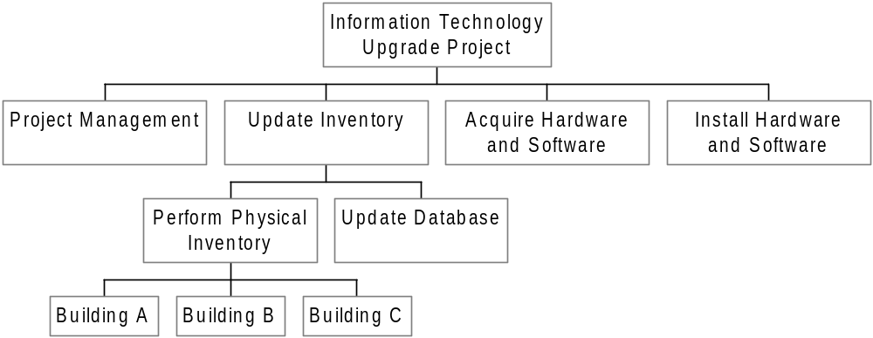
- Create a WBS for one of the following projects:
  - Building your dream house
  - Planning a traditional wedding
  - Creating a new information system for your school or company
Break down the work to at least the third level for one of the items on the WBS. Enter the WBS into Project 2002 and print out the Gantt chart. Do not enter any durations or dependencies. Make notes of questions you
had while completing this exercise.
SOLUTION: Answers will vary. Be sure the WBSs make sense, include all the work required for the project, and follow a hierarchy based on major deliverables and/or phases of work. Below is one possible WBS for building a house. There is a Project 2002 general template for commercial construction that you can use as an example, too. See the solution for the running case for planning a wedding (case 3 in Appendix C) for an example WBS and Gantt chart for a wedding.
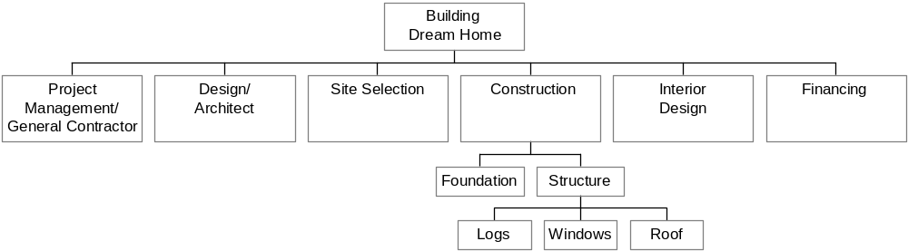

- Review the files in the Microsoft Project 2002 templates folder. What do you think about the WBSs for them? Try drawing a WBS in chart form for one of the sample templates. Draw the WBS by hand or try using the Visio WBS Chart Wizard add-in tool described in Appendix A.
SOLUTION: Answers will vary.
- Perform a financial analysis for a project using the format provided in Figure 5-3. Assume the projected costs and benefits for this project are spread over four years as follows: Estimated costs are $1,500,000 in year 1 and $300,000 each year in years 2, 3, and 4. Estimated benefits are $0 in year 1 and $1,000,000 each year in years 2, 3, and 4. Use a 10 percent discount rate. Create a spreadsheet to calculate and clearly display the NPV, ROI, and year in which payback occurs. In addition, write a paragraph explaining whether you would recommend investing in this project, based on your financial analysis.
SOLUTION: Below is a spreadsheet with the correct answers. Since the project has a positive NPV, it can be viewed as a good investment. However, the ROI could be higher (10.72% is good but not great), and the payback is not until year 4.

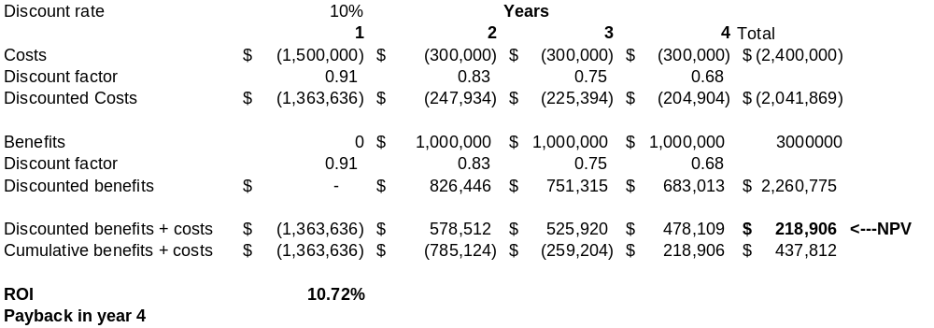
- Read one of the suggested readings or find an article related to project scope management. Write a one-page summary of the article, its key conclusions, and your opinion.
SOLUTION: Answers will vary.

MINICASE
A financial services company has a long list of potential projects to consider this year. Managers at this company must decide which projects to pursue and how to define the scope of the projects selected for approval. The company has decided to use a weighted scoring model to help in project selection, using criteria that map to corporate objectives. All projects selected must develop a WBS using corporate guidelines.
Part 1: You are part of a team that will analyze proposals and recommend which projects to pursue. Your team has decided to create a weighted scoring model using the following criteria and weights:
Criteria Weight
1. Enhances new product development 20%
2. Streamlines operations 20%
3. Increases cross-selling 25%
4. Has good NPV 35%
To determine the score for the last criterion, your team has developed the following scoring system:
- NPV is less than 0, the score is 0
- NPV is between 0 and $100,000, the score is 25
- NPV is between $100,000 and $200,000, the score is 50
- NPV is between $200,000 and $400,000, the score is 75
- NPV is above $400,000, the score is 100
The following is information for three potential projects:
- _ Project 1: Scores for criteria 1, 2, and 3 are 10, 20, and 80, respectively. Estimated costs the first year are $500,000, and costs for years 2 and 3 are $100,000 each. Estimated benefits for years 1, 2, and 3 are $200,000, $400,000, and $600,000, respectively.
- _ Project 2: Scores for criteria 1, 2, and 3 are all 50. Estimated costs the first year are $700,000, and costs for the second year are $200,000. Estimated benefits for years 1 and 2 are $300,000 and $700,000, respectively.
- _ Project 3: Scores for criteria 1, 2, and 3 are 0, 50, and 80, respectively. Estimated costs the first year are $300,000, and costs for years 2, 3, and 4 are $100,000 each. Estimated benefits for years 1, 2, 3, and 4 are $0, $600,000, $500,000, and $400,000, respectively.
Develop a spreadsheet to calculate the NPVs and weighted scores for the three projects. Use a 10 percent discount rate for the NPV calculations.

SOLUTION: Note: This file (ch5mini1_solution.xls) is available on the Instructor Resource CD-Rom.
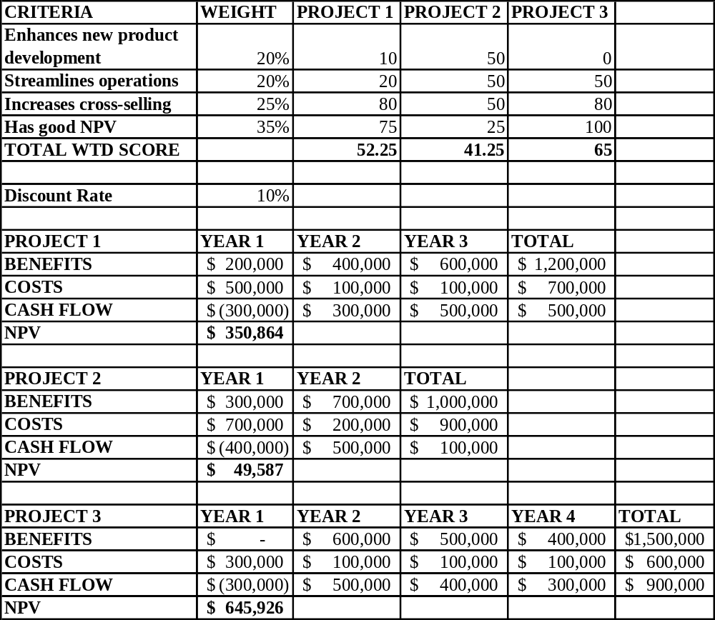
Part 2: One project selected for initiation is development of an expert system that current customers can use to give them advice on other financial products and services that would meet their needs. Corporate guidelines for creating project WBSs are to use the five project management process groups as level 1 in the WBS. Each process group must have at least one major deliverable, such as a signed project charter for initiating, an approved project plan for planning, monthly status reports for controlling, and a final report, presentation, and lessons learned for closing. The deliverables for execution vary by project. Use the corporate guidelines to develop a WBS in tabular form. The categories of initiating, planning, executing, controlling, and closing are the level 1 categories. For the executing section, include level 2 categories of analysis, design, prototyping, testing, implementation, and support. Assume the support category includes level 3 categories of training, documentation, user support, and enhancements. Create the WBS in Project 2002, indenting categories appropriately. Use the outline numbering feature to display the outline numbers (under Tools, Options, Show outline number.) For example, your WBS should start with 1.0 Initiating. See Appendix A or Project 2002’s Help for assistance. Print out the resulting Gantt chart, being sure to display the entire Task Name column.
SOLUTION: Below is one potential solution. This file (ch5mini2_solution.mpp is available on the Instructor Resource CD-Rom.
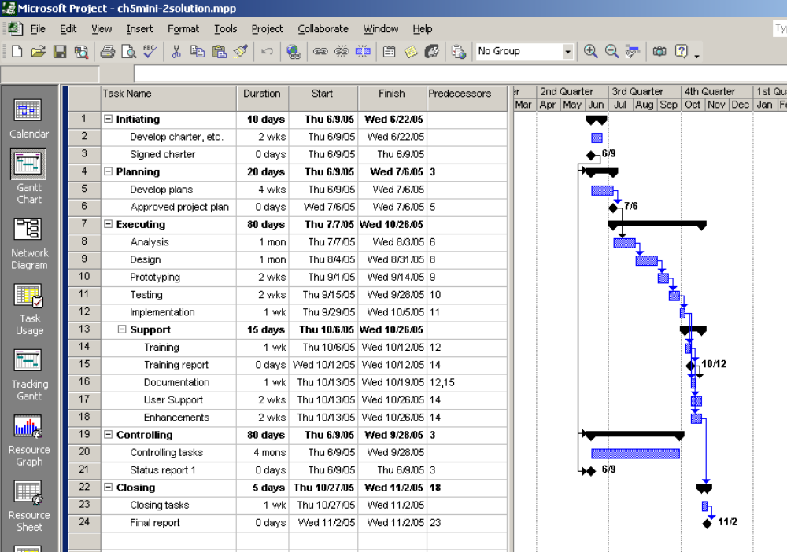
CHAPTER 6

Project Time Management

DISCUSSION QUESTIONS
    - Why do you think schedule issues often cause the most conflicts on projects?
Many people are juggling many different tasks, both related to their jobs and their personal lives. It is difficult to schedule good meeting times for all project stakeholders, and face-to-face meetings are still important in various aspects of projects. Many people also underestimate how long things will take and the degree to which certain tasks depend on other tasks being completed. People do not like wasting time, and poor time management often wastes time.
- Why is activity definition the first process involved in project time management?
You cannot determine activity sequencing or develop good activity duration estimates unless you have a good understand of each activity, so you need to perform activity definition first.
- Why is it important to determine activity sequencing on projects? Discuss diagrams you have seen that are similar to network diagrams. How are they similar, and how are they different?
You cannot determine the critical path for a project unless you sequence activities. Several different diagrams are similar to project network diagrams. In transportation modeling, for example, you try to find the shortest route between two points. In those diagrams, however, you only need to take one path. In a project network diagram, all activities must be completed in order to complete the project.
- Explain the difference between activity duration estimating and estimating the effort required to perform an activity.
The effort estimate related to how many hours will be spent performing an activity. The activity duration estimate includes the effort as well as how much time passes on a calendar in order to generate the project schedule. For example, an activity might only take 8 work hours to complete, but if it is done one hour per workday, it will take more than a week on the project’s Gantt chart.
  - Explain the following schedule development tools and concepts: Gantt charts, critical path method, PERT, and critical chain scheduling.
A Gantt chart displays a project schedule in a calendar format. The critical path for a project determines the earliest completion time for a project. PERT is a network analysis technique where you apply a weighted average to determine the duration estimate for tasks. Critical chain scheduling accounts for resource constraints and suggests that you limit multitasking of resources in creating project schedules and include project and feeding buffers to protect the project completion date.
  - How can you minimize or control changes to project schedules?
Answers will vary. It is important to develop realistic schedules and use leadership and discipline to meet schedule deadlines.
  - List some of the reports you can generate with Project 2002 to assist in project time management.
Project 2002 includes overview reports of critical tasks and milestones reports, current activities reports of unstarted tasks, tasks starting soon, tasks in progress, completed tasks, should have started tasks, and slipping tasks and an assignment report called who does what and when.
  - Why is it difficult to use project management software well?
Project management software is very powerful. It also assumes that the user knows how to create a good WBS, enter task durations and dependencies, and understand basic concepts of project management.

EXERCISES
1. Using Figure 6-2, enter the activities, their durations, and their relationships in Project 2002. Use a project start date of 6/01/05. View the network diagram. Does it look like Figure 6-2? It should be very similar, but appear in PDM form, as shown in Figure 6-4. Print the network diagram on one page. Return to Gantt chart view. Select View, Table, Schedule from the menu bar to recreate Table 6-1. You may need to move the split bar to the right to reveal all of the table columns. Write a few paragraphs explaining what the network diagram and schedule table show concerning Project X’s schedule.
SOLUTION: The Gantt chart and network diagram are shown below. The network diagram shows the relationship between project activities. In other words, it shows what tasks have dependencies. The critical path automatically displays in red in Project 2002 (B-E-H-J). If any activity on the critical path takes longer than planned, the entire project will be delayed.
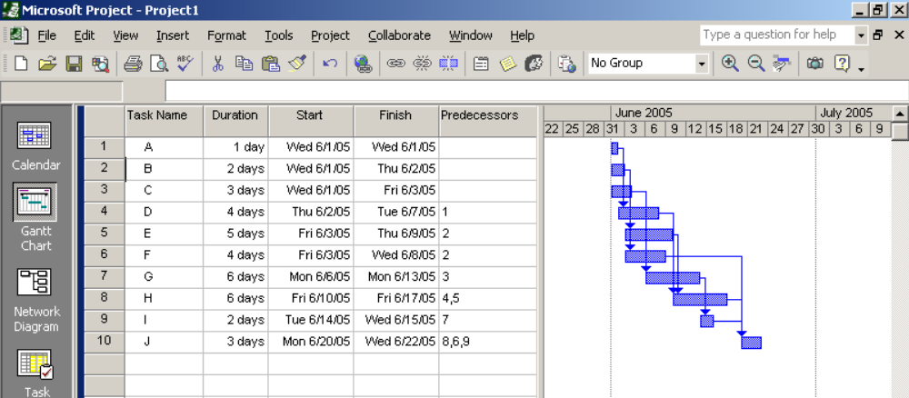
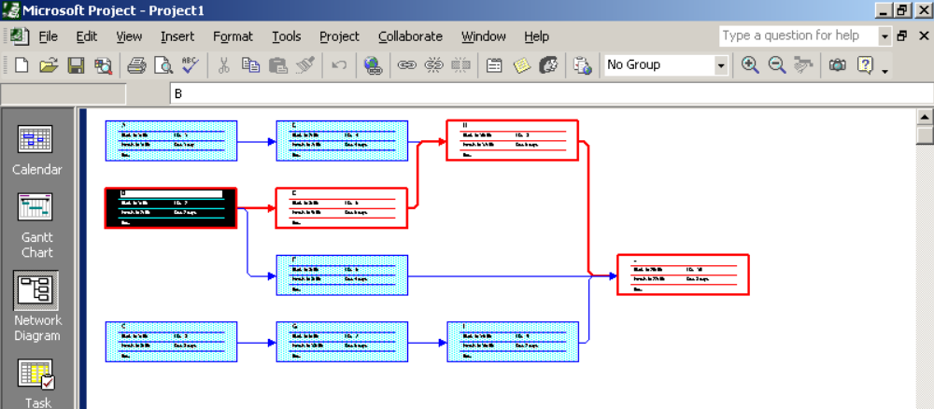
2. Consider Table 6-3, Network Diagram Data for a Small Project. All times are in days; the network proceeds from Node 1 to Node 9.
a. Draw an AOA network diagram representing the project. Put the node numbers in circles and draw arrows from node to node, labeling each arrow with the activity letter and estimated time.
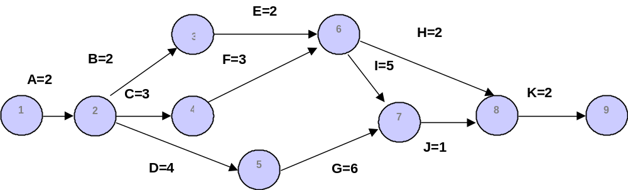
SOLUTION: Below is the network diagram.
b. Identify all of the paths on the network diagram and note how long they are.
SOLUTION:
Path 1: A-B-E-H-K Length = 2+2+2+2+2 = 10 days
Path 2: A-B-E-I-J-K Length = 2+2+2+5+1+2 = 14 days
Path 3: A-C-F-H-K Length = 2+3+3+2+2 = 12 days
Path 4: A-C-F-I-J-K Length = 2+3+3+5+1+2 = 16 days
Path 5: A-D-G-J-K Length = 2+4+6+1+2=15 days

c. What is the critical path for this project and how long is it?
SOLUTION: The critical path is A-C-F-I-J at 16 days
d. What is the shortest possible time it will take to complete this project?
SOLUTION: 16 days
3. Enter the information from Exercise 2 into Project 2002. View the network diagram and task schedule table to see the critical path and float or slack for each activity. Print out the Gantt chart and network diagram views and the task schedule table. Write a short paper that interprets this information for someone unfamiliar with project time management.
SOLUTION: Below are several outputs. Dates will vary based on when the students enter the information.

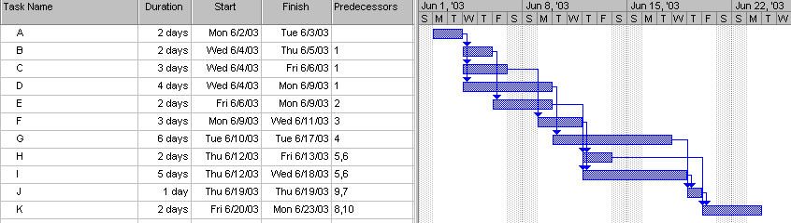
Gantt chart:
Network diagram.
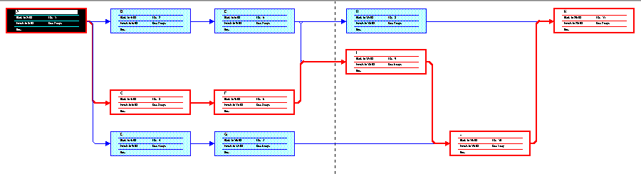
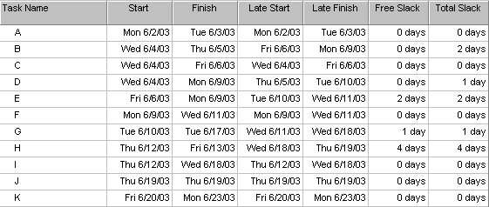
Task schedule table:

Answers for the short paper will vary. Students should note that the critical path is A-C-F-I-J-K. If any of these tasks take longer than planned, the entire project will be delayed. If they take less time than planned, the project could be finished early. The schedule table lists the amount of slack each activity has. The slack is the amount of time the activity can be delayed without delaying another activity (free slack) of the entire project (total slack).
4. Perform the following steps:
a. Using the Information Technology Upgrade Project WBS you created in Chapter 5, Exercise 2, manually create a rough Gantt chart for the project. Make sure the project does not take more than nine months
to complete. Document any assumptions you made in creating the Gantt chart.
b. Determine the relationships between activities listed on your WBS and the Gantt chart. Manually build a network diagram for this project. Estimate the duration of each activity, and then enter the data into Project 2002. Make sure you can complete the project in nine months or less. Print the Gantt chart and network diagram and write a one-page paper interpreting the results.
SOLUTION: Answers will vary.
5. Interview someone who uses some of the techniques discussed in this chapter. How does he or she feel about network diagrams, critical path analysis, Gantt charts, critical chain scheduling, using project management software, and managing the people issues involved in project time management? Write a paper describing the responses.
SOLUTION: Answers will vary.
6. Review two different articles about critical chain scheduling. Write a two- to three-page paper describing how this technique can help improve project schedule management.
SOLUTION: Answers will vary.

MINICASE
You have been asked to determine a rough schedule for a nine-month Billing System Conversion project, as part of your job as a consultant to a Fortune 500 firm. The firm’s old system was written in COBOL on a mainframe computer, and the maintenance costs are prohibitive. The new system will run on an off-the-shelf application. You have identified several high-level activities that must be done in order to initiate, plan, execute, control, and close the project. The following table shows your analysis of the project’s tasks and schedule so far.6
Part 1: Using the information in the table, draw horizontal bars to illustrate when you think each task would logically start and end. Then use Microsoft Project 2002 to create a Gantt chart and network diagram based on this information.
SOLUTION: Answers will vary. Below is one possible solution. Dates will vary based on the start date used.
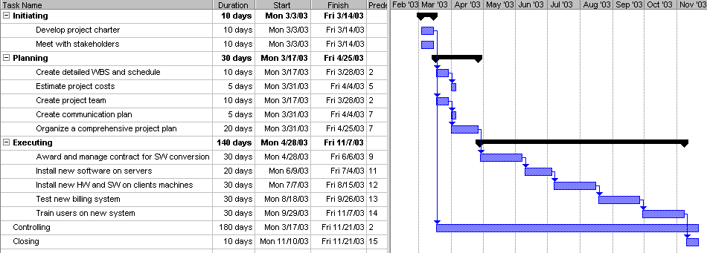
Part 2: Identify at least two milestones that could be included under each of the process groups in the table. Then write a detailed description of each of these milestones that meets the SMART criteria.
SOLUTION: Answers will vary. Potential milestones include the following:
- Initiating: Charter developed, project manager assigned, funding approved
- Planning: Draft WBS completed, baseline plan completed, cost estimate approved, project team assigned, communications plan distributed
- Executing: Contract awarded, server software installed, client hardware installed, client software installed, testing completed, training completed
- Controlling: Change control procedures established, change control board established
- Closing: Final project report completed, final project presentation completed, lessons learned distributed

CHAPTER 7

Project Cost Management

DISCUSSION QUESTIONS
      - Discuss why many information technology professionals have a poor attitude toward project cost management and how this attitude might affect the poor track record for completing projects within budget.
Many information technology professionals have a poor attitude toward project cost management because they have had bad experiences in the past, they think it is a job for accountants, and they have not been trained on creating and adhering to cost estimates. This negative attitude contributes to the poor track record of completing projects within budget.
    - Explain some of the basic principles of cost management, such as profits, life cycle costs, tangible and intangible costs and benefits, direct and indirect costs, reserves, and so on.
Definitions of all of these terms are provided in the text and key terms
    - Give examples of when you would prepare rough order of magnitude, budgetary, and definitive cost estimates for an information technology project. Give an example of using each of the following techniques for creating a cost estimate: analogous, parametric, bottom-up, and computerized tools.
Answers will vary. A rough order of magnitude estimate for providing new laptops for 100 people might be $250,000. A budgetary estimate would break down the estimate to include hardware, software, detailed assumptions (for example, if the estimate is just for the purchase cost or is for a 2 to 4 year project life), and so on. A definitive estimate would be much more detailed and accurate than a rough estimate or budgetary estimate and would include vendor quotes.

Using the example of providing new laptops for 100 people, one possible response for examples of each type of estimating techniques follows:
- Analogous estimate: You could research similar organizations that recently purchased about the same number and type of laptops.
- Parametric estimate: You could decide on key factors, such as the basic category of laptop required and other requirements, and estimate costs using those parameters. For example, you might estimate that the laptops would cost about $2,000 each and that another $500 per unit would be required for support costs.
- Bottom-up estimate: You could determine detailed hardware and software requirements, training, and support costs to create an estimate.
- Computerized tools: You could use a spreadsheet to help prepare a cost estimate.
    - Explain what happens during the cost budgeting process.
Project cost budgeting involves allocating the project cost estimate to individual work items over time to create a cost baseline. For example, you may need to break down costs into specific categories like travel, compensation, etc. for each month so funds can be allocated and tracked.
    - Explain why earned value management is the preferred method for measuring project performance and speculate as to why it is not used more often. What are some general rules of thumb for deciding if cost variance, schedule variance, cost performance index, and schedule performance index numbers are good or bad?
Earned value analysis is a project performance technique that integrates scope, time, and cost data. It is the preferred method for measuring project performance because it includes all three dimensions of the triple constraint. It is not used more often because it is difficult to create a good baseline for cost, time, and scope estimates, and it is difficult to enter actual information (percentage of work complete and actual time and cost numbers) in a timely manner. Negative variance numbers are bad. For example, a cost variance of -$1000 means it cost more than planned. A performance index below 100 percent is bad. For example, a schedule performance index of 80 percent means the project or activity is behind schedule.
    - What is project portfolio management? Can project managers use it with earned value management?
Project portfolio management is when organizations collect and control an entire suite of projects or investments as one set of interrelated activities. Yes, you can use earned value management along with project portfolio management.
    - Describe several types of software that project managers can use to support project cost management.
Spreadsheet software is often used to develop cost estimates, budgets, and other cost management information. There are also specialized financial applications software packages, project management software, and portfolio management software to assist with project cost management.

EXERCISES
- Given the following information for a one-year project, answer the following questions. Recall that PV is the planned value, EV is the earned value, AC is the actual cost, and BAC is the budget at completion.
PV= $23,000
EV= $20,000
AC= $25,000
BAC= $120,000
a. What is the cost variance, schedule variance, cost performance index
(CPI), and schedule performance index (SPI) for the project?
SOLUTION:
- Cost variance = EV-AC=$20,000 - $25,000 = -$5,000
- Schedule variance = EV-PV=$20,000-$23,000=-$3,000
- CPI=EV/AC=$20,000/$25,000 =80% or .8
- SPI=EV/PV=$20,000/$23,000=87% or .87
b. How is the project doing? Is it ahead of schedule or behind schedule? Is
it under budget or over budget?
SOLUTION: The project is over budget and behind schedule.
c. Use the CPI to calculate the estimate at completion (EAC) for this project.
Is the project performing better or worse than planned?
SOLUTION: EAC=BAC/CPI=$120,000/.8=$150,000
The project is performing worse than planned since the new estimate to complete it is $30,000 more than planned.
d. Use the schedule performance index (SPI) to estimate how long it will take to finish this project.
SOLUTION: Estimated time to complete=12months/.87=13.8 months. The project is projected to take 1.8 months longer than planned.
- Using the data in Figure 7-2 for cumulative PV, AC, and EV, create an earned value chart similar to the one shown in Figure 7-3.
SOLUTION: The chart should resemble Figure 7-3. You can access the file (ch7ex2-solution.xls) on the Instructor Resource CD-Rom.
3. Create a cost estimate for building a new, state-of-the-art multimedia classroom for your organization within the next six months. The classroom should include twenty high-end personal computers with appropriate software for your organization, a network server, Internet access for all machines, a teacher station, and a projection system. Be sure to include personnel costs associated with the project management for this project. Document the assumptions you made in preparing the estimate and provide explanations for key numbers.
SOLUTION: Answers will vary. Be sure students document assumptions and provide explanations for key numbers.
4. Research online information, textbooks, and local classes for using the cost management features of Microsoft Project 2002. Ask three different people in different information technology organizations that use Microsoft Project 2002 if they use the cost management features and in what ways they use them. Write a brief report of what you learned from your research.
SOLUTION: Answers will vary.
5. Research three different products to assist organizations in project portfolio management. Microsoft, Pacific Edge, PlanView, Artemis, and Welcom are just a few companies that provide products for project portfolio management. Write a one- to two-page paper summarizing your results.
SOLUTION: Answers will vary.
6. Perform the project cost management part of one of the exercises or case studies provided in Appendix A or Appendix C. Print the reports or information required and write a one-page paper interpreting the results.
SOLUTION: See the solution files for Appendix A and Appendix C.

MINICASE
You have decided that you are now an expert in project cost estimating, and you want to hold some public classes or workshops on this topic. You completed some training in the past, which has given you confidence in your abilities. Your first project is to develop materials, then market and hold your first seminar. You plan to do all of the work within the next six months. You want to create a good cost estimate for this project. Below are some of your assumptions:
- You will charge $600 per person for a two-day class.
- You estimate that 30 people will attend.
- Your fixed costs include $500 to rent a room for both days, setup fees of $400 for registration, and $300 for designing a postcard for advertising.
- You will not include any of your labor costs for this estimate, but you estimate that you will spend at least 150 hours developing materials, managing the project, and giving the actual class. You would like to know what your time is worth given different scenarios.
- You will order 5,000 postcards, mail 4,000, and distribute the rest to friends and colleagues.
Your variable costs include the following:
a. $5 per person for registration plus 4 percent of the class fee per person to handle credit card processing. Assume everyone pays by credit card.
b. $.40 per postcard if you order 5,000 or more
c. $.25 per postcard for mailing and postage
d. $25 per person for beverages and lunch
e. $30 per person for class handouts
Assume 30 people register for and attend the class.
Part 1: Using Excel, create a spreadsheet to calculate your projected total costs, total revenues, and total profits given the preceding information. Be sure to have input cells for any variables that might change, such as the cost of postage, handouts, and so on. Calculate your profits based on the following number of people who attend: 10, 20, 30, 40, 50, and 60. In addition, calculate what your time would be worth per hour based on the number of students. Try to use the Excel Scenario feature (under the Tools menu) to create a scenario pivot table showing total profits based on the number of people who attend. You could also create a data table showing the profits based on the number of students. If you are unfamiliar with the Scenario feature or data tables, just repeat the calculations for each possibility of 10, 20, 30, 40, 50, and 60 students.
SOLUTION: Below is one potential spreadsheet layout. The profits for each scenario should be as shown, but students may have different spreadsheet designs. You can access the Excel file named ch7mini1_solution.xls on the Instructor Resource CD-Rom.

Cost Estimating Seminar | Chapter 7 Minicase
Projected Revenues
# people | 10 | 20 | 30 | 40 | 50 | 60
price/person | $ 600 | $ 600 | $ 600 | $ 600 | $ 600 | $ 600
Total | $ 6,000 | $ 12,000 | $ 18,000 | $24,000 | $ 30,000 | $ 36,000
Projected Expenses
Room fee | $ 500 | $ 500 | $ 500 | $ 500 | $ 500 | $ 500
Registration setup fee | $ 400 | $ 400 | $ 400 | $ 400 | $ 400 | $ 400
Postcard design | $ 300 | $ 300 | $ 300 | $ 300 | $ 300 | $ 300
Registration variable costs | $ 50 | $ 100 | $ 150 | $ 200 | $ 250 | $ 300
Credit card processing variable costs | $ 240 | $ 480 | $ 720 | $ 960 | $ 1,200 | $ 1,440
Postcard variable costs | $ 2,000 | $ 2,000 | $ 2,000 | $ 2,000 | $ 2,000 | $ 2,000
Postcard mailing and postage | $ 1,000 | $ 1,000 | $ 1,000 | $ 1,000 | $ 1,000 | $ 1,000
Beverages and lunch | $ 250 | $ 500 | $ 750 | $ 1,000 | $ 1,250 | $ 1,500
Class handouts | $ 300 | $ 600 | $ 900 | $ 1,200 | $ 1,500 | $ 1,800
Total | $ 5,040 | $ 5,880 | $ 6,720 | $ 7,560 | $ 8,400 | $ 9,240
Projected Profits | $ 960 | $ 6,120 | $ 11,280 | $16,440 | $ 21,600 | $ 26,760
Value of personal time/hour | $ 6.40 | $ 40.80 | $ 75.20 | $109.60 | $ 144.00 | $ 178.40
Variable costs
Registration | $ 50 | $ 100 | $ 150 | $ 200 | $ 250 | $ 300
Credit card processing | $ 240 | $ 480 | $ 720 | $ 960 | $ 1,200 | $ 1,440
Postcards | $ 2,000 | $ 2,000 | $ 2,000 | $ 2,000 | $ 2,000 | $ 2,000
Postcard mailing and postage | $ 1,000 | $ 1,000 | $ 1,000 | $ 1,000 | $ 1,000 | $ 1,000
Beverages and lunch | $ 250 | $ 500 | $ 750 | $ 1,000 | $ 1,250 | $ 1,500
Class handouts | $ 300 | $ 600 | $ 900 | $ 1,200 | $ 1,500 | $ 1,800
Unit costs and other info
# postcards made | 5,000 | 5,000 | 5,000 | 5,000 | 5,000 | 5,000
# postcards mailed | 4,000 | 4,000 | 4,000 | 4,000 | 4,000 | 4,000
Registration/person | $ 5.00 | $ 5.00 | $ 5.00 | $ 5.00 | $ 5.00 | $ 5.00
Credit card fee/person (4% * fee ($600) | $ 24.00 | $ 24.00 | $ 24.00 | $ 24.00 | $ 24.00 | $ 24.00
Postcards (each) | $ 0.40 | $ 0.40 | $ 0.40 | $ 0.40 | $ 0.40 | $ 0.40
Postcard mailing and postage (each) | $ 0.25 | $ 0.25 | $ 0.25 | $ 0.25 | $ 0.25 | $ 0.25
Beverages and lunch/person | $ 25.00 | $ 25.00 | $ 25.00 | $ 25.00 | $ 25.00 | $ 25.00
Class handouts/person | $ 30.00 | $ 30.00 | $ 30.00 | $ 30.00 | $ 30.00 | $ 30.00
Person hours spent | 150 | 150 | 150 | 150 | 150 | 150

Part 2: Research the local market (or the location of your choice) for short classes on topics similar to project cost estimating. Find at least three organizations that offer estimating courses. You can search the Registered Education Provider’s database for organizations from PMI’s Web site (www.pmi.org), using “estimating” in the title. Given your research into similar classes and the work you think is required for this project, what assumptions, variables, or costs would you change from the information provided above? Justify your changes to the estimate, and create a spreadsheet with your best estimate for this project. Then write a paragraph describing whether you think this particular project is worth pursuing.
SOLUTION: Answers will vary. Many new companies and consultants have entered the project management training market in the past few years.

Part 3: (Note: The first run of the text forgot to label this paragraph Part 3.) Review Appendix A, especially the section on project human resource and cost management. Do you think you could create a cost estimate for this workshop using Project 2002? Why or why not? Write a one- to two-page paper describing why this type of project (giving a workshop) is or is not a good candidate for using Project 2002 cost management features.
SOLUTION: Answers will vary. Since this estimate does not have a specific set of tasks and labor costs are not part of the estimate, it is not a good candidate for Project 2002. Excel is a better tool for cost modeling where there can be several variables in this estimate.

CHAPTER 8

Project Quality Management

DISCUSSION QUESTIONS
  - Discuss some of the examples of poor quality in information technology projects presented in the “What Went Wrong?” section. Could most of these problems have been avoided? Why do you think there are so many examples of poor quality in information technology projects?
Many of these problems could be avoided by performing better quality management. One problem is that software and hardware is hitting the market too fast, so people selling these might be more concerned about money than safety or well being of the consumers or the company in the long term.
  - What are the main processes included in project quality management?
The project quality management processes include quality planning, quality assurance, and quality control.
  - How do functionality, system outputs, performance, reliability, and maintainability requirements affect quality planning?
All of these factors affect quality planning because they will drive the requirements that need to be met to ensure quality.
  - What type of information goes in a quality assurance plan?
Table 8-1 on p. 268 provides a table of contents for a quality assurance plan.
  - What are the three main outputs of quality control?
The three main outputs of quality control are acceptance decisions, rework, and process adjustments.
  - Provide examples of when you would use a Pareto diagram, statistical sampling, quality control charts, and testing on an information technology project.
Answers will vary. See the examples provided in the text.
  - Discuss the history of modern quality management. How have experts such as Deming, Juran, Crosby, and Taguchi affected the quality movement and today’s use of Six Sigma?
These experts have made quality a visible criterion that companies strive to achieve. Awards have been established to seek quality and reward those who have achieved it. Quality projects have been used to meet customer expectations instead of only company needs. A wider scope of what quality is and isn't has been developed to provide benchmarking criteria for businesses. Pointing out the cost of poor quality will give motivation to companies and increase their desire for quality. U.S. businesses observed BOTH the emphasis on quality in other nations AND those nations' successes in the marketplace. It was the economic success attributable to the emphasis on quality that made U.S. companies sit up and take notice.
  - Discuss three suggestions for improving information technology project quality that were not made in this chapter.
Answers will vary. Some ideas would be providing better training for people in information technology to produce better quality, providing incentives for meeting quality goals, establishing minimum quality requirements for specific IT products, and so on.
  - Describe three different types of software that can assist in project quality management.
You can use spreadsheet software, databases, charting software, statistical software, and other specialized software for quality management.

EXERCISES
Answers to all of these exercises will vary. The exercises, and some possible solutions, are provided here for your convenience.
1. Research progress that has been made in improving the quality of information technology projects. Write a one- to two-page paper discussing your findings.
2. Assume your organization wants to hire new instructors for your project management course. Develop a list of quality standards that you could use in making this hiring decision.
3. To illustrate a normal distribution, shake and roll a pair of dice thirty times and graph the results. It is more likely for someone to roll a six, seven, or eight than a two or twelve, so these numbers should come up more often. To create the graph, use graph paper or draw a grid. Label the x-axis with the numbers two through twelve. Label the y-axis with the numbers one through eight. Fill in the appropriate grid for each roll of the dice. Do your results resemble a normal distribution? Why or why not?
ANSWER: Answers will vary, but the results should have more occurrences of numbers between 5 and 9 and less of the other numbers. One solution from a former student follows:
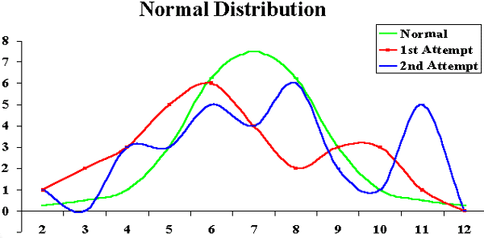

4. Research the criteria for the Malcolm Baldrige National Quality Award. Investigate a company other than Motorola that has received this award. What steps did the company take to earn this prestigious quality award? What are the benefits of earning this award?
ANSWER: Answers will vary. The following solution is from a former student.

The Malcolm Baldrige National Quality Award has been created to emphasize quality as a national priority in a competitive world market. Winners are chosen for this award based on seven criteria that thoroughly investigate all companies that apply. The first of the criteria is leadership. This examines how senior executives guide the company as well as how the company addresses its responsibilities to the public by practicing good citizenship. Second is strategic planning which measures how the company sets strategic directions and how it determines key action plans. Customer and Market Focus criteria analyze how the company determines requirements and expectations of customers and markets. Information and Analysis tests management's effectiveness when using and analyzing data and information to support key company processes and the company's' performance management system. Fifth is Human Resource Development and Management. This examines how the company enables its work force to develop its company's objectives. Process Management measures the aspects of how key deliveries, production, and support processes are designed, managed, and improved. Finally, Business Results test the company's performance and improvement in key business areas.

In 1997 3M Dental Products won this prestigious award. 3M built their Dental division according to the standards the Malcolm Baldrige National Quality Award has set. Outstanding effort and achievement in all seven categories of award criteria led 3M's Dental division to its victory.

Leadership was accomplished by a detailed leadership system, which includes a strategic plan process, a business process management matrix, functional and operational reviews and teaming approach, and employee contribution and development plans. Leadership also aligns public responsibility with performance improvement and encourages employees to volunteer with support and recognition.

Strategic Planning at 3M Dental is supported by a "One Global Plan." This plan is developed by employees from branches all around the world to maintain the same focus and goals for all divisions. Strategic Planning is also successful at pulling together vast amounts of data and information for analysis, determining priorities, defining approaches, the assignment of responsibilities, resource allocation, and aligning activities toward 3M's vision.

Customer and Market Focus deal with customer segmentation, listening to the customer, relationship building, leveraging 3M corporate capability, and customer relations. Each of these elements work together to increase dentist usage of 3M products, rather than attracting new audiences. This system also handles all complaints directly and on the spot.

Information and Analysis deals with company information and data as well as company performance and review. The selection and use of company information has four steps: 1) monitor business performance for alignment with strategic planning, 2) identify improvement opportunities, 3) initiate and drive corrective action, and 4) feedback into the Strategic Planning Process. 3M's Customer Information Systems database includes: all purchases of 3M Dental and competitive products, contact activity, complaints by the segment market, and complaints by dentists. Competitive data is kept to aid in benchmarking and foreseeing improvements in performance.

Human Resources use a team approach and education and job satisfaction. The team approach gives employees a comprehensive training and skill development program, fairly designed recruiting programs, and properly established recognition and compensation programs. Education and job satisfaction enables employees to receive the proper schooling or training they feel they need to perform their best.

Process Management has three areas. Product and Services keep a product introduction checklist for each product to help with benchmarking. Management Support surveys internal, external, customer requirements, benchmarking and comparisons, and knowledge of available technology. Supplier Management maintains clear communication of requirements, certifies key suppliers, and provides performance feedback to suppliers.

Business Results have been clear. Because of the organization and quality focus of 3M Dental Products they have been able to deliver their promise, reach high levels of customer satisfaction, have continued financial success, and production efficiency. Each of these being key benefits for the company and the business they provide.

5. Review the information in this chapter about Six Sigma principles and Six Sigma organizations. Brainstorm ideas for a potential Six Sigma project that could improve quality on your campus, at your workplace, or in your community. Write a one- to two-page paper describing one project idea and why it would be a Six Sigma project. Review and discuss how you could use the DMAIC process on this project.
6. Review the concepts in this chapter related to improving the quality of software. Write a one- to two-page paper describing how you could apply these concepts to software development projects.

MINICASE
You are part of a team analyzing quality problems that you have been having with your call center/customer service area. After studying customer complaints, you have categorized and logged them for a week as follows:
Part 1: Create a Pareto diagram based on the information in the table below. First, create a spreadsheet in Excel, using the data in the table below. List the most frequent customer problems first. Add a column called “% of Total” and another one called “Cumulative %.” Then enter formulas to calculate those items. Next, use the Excel Chart Wizard to create a Pareto diagram based on this data. Use the Line—Column on 2 Axis custom type chart so your resulting chart looks similar to the one in Figure 8-1.
SOLUTION: See the following spreadsheet. You can access this file, ch8mini1_solution.xls from the Instructor Resources material.
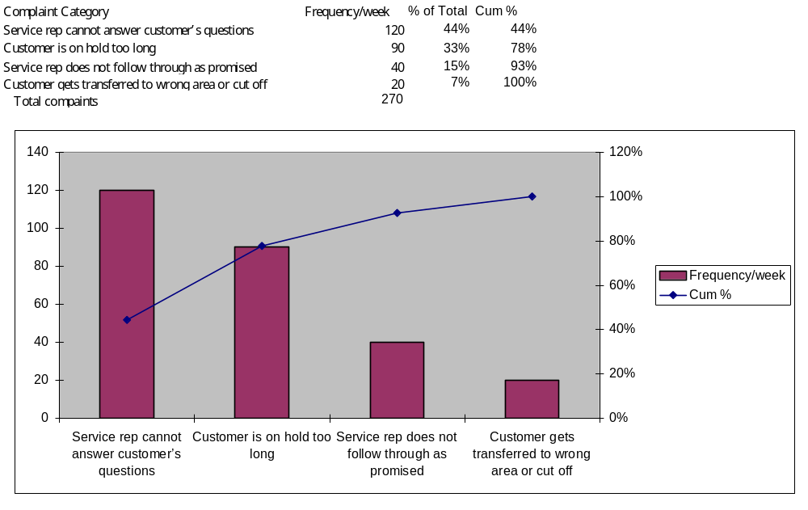
Part 2: Your team has decided to add some customer service features to your Web site. You believe that having “Frequently Asked Questions” and answers will help reduce the complaints about service reps not being able to answer customers’ questions and will lower the volume of calls. Customers and service reps could access information through this new Web page. However, you know that just as people complain about call centers, they also complain about Web sites. Develop a list of at least four potential complaints that your customers and service reps might have about this new Web page, and then describe your plans for preventing those problems. Describe also how this new Web page could continuously help to improve the quality of service provided by your call center/customer service area.
SOLUTION: Answers will vary. Possible complaints about the new Web site include the following:
- Customers may want to talk to a service rep instead of looking up information on the Web.
- The Web site may be too hard to navigate.
- The information might be outdated or not what the customer expects.
- The Web site may be too slow to load.
- The Web site url may be too hard to remember.
Possible solutions will vary depending on the complaints listed.
CHAPTER 9

Project Human Resource Management

DISCUSSION QUESTIONS
- Discuss the changes in the job market for information technology workers. How does the job market and current state of the economy affect human resource management?
The job market changed dramatically after 2000. When there is a shortage of workers, companies often provide higher pay and incentives. Organizations still need to treat people well regardless of the market situation. Many people in IT realize that skills like project management and business analysis are even more important in a challenging economic environment.
- Summarize the processes involved in project human resource management.
The processes include organizational planning, staff acquisition, and team development. See p. 311 for a brief summary of each process.
- Briefly summarize the work done by Maslow, Herzberg, McClellan, McGregor, Ouchi, Thamhain and Wilemon, and Covey. How do their theories relate to project management?
The text summarizes key contributions of each of these people. Answers to how their theories related to project management will vary.
- Describe situations where it would be appropriate to create a project organizational chart, a responsibility assignment matrix, a RACI chart, and a resource histogram. Describe what these charts or matrices look like.
Large projects should have a project organizational chart. When it’s important to clarify roles and responsibilities for tasks, a RAM can be helpful. A RACI chart is a type of RAM that clarifies who has responsibility, accountability, consultation, and informed roles on a project. A resource histogram shows the number of people by skill required each time period for a project. See samples of each chart in the text.
- Discuss the difference between resource loading and resource leveling and provide an example of when you would use each technique.
Resource loading helps you see what people are scheduled to work on projects and when they are scheduled to work. Resource leveling helps you to smooth out resource allocations and reduce scheduling conflicts. Both of these techniques make it easier to manage human resources.
- Explain two different types of team-building activities described in this chapter.
The two types of activities are physical challenges like ropes courses or basic training and psychological preference indicator tools like MBTI or the social styles profile.
- How can you use Project 2002 to assist in project human resource management?
You can enter resource information, such as names, categories, availability, costs, and so on in Project 2002 and assign those resources to specific tasks. You can also view resource histograms and level resources with Project 2002. See Appendix A for more details.

EXERCISES
Answers to all of these exercises will vary. The exercises, and some possible solutions, are provided here for your convenience.
- Develop a responsibility assignment matrix for building a new state-of-the- art multimedia classroom for your university. Assume the faculty in the Computer Science/MIS Department received a grant to lead this project. The grant includes funds for all of the hardware and software plus some money for faculty and student labor. Also assume the university must match the funds provided by the granting agency. Key stakeholders are faculty who might use the facility, students, the Dean, the head of facilities, the head of finance, and the head of information technology. Major activities might include deciding where to put the classroom, defining the classroom configuration (number and type of computers, projections system software, layout, and so on), writing a request for proposal, evaluating proposals, overseeing the winning contractor, obtaining matching funds from the college, surveying faculty and students on the use of the classroom, providing training on using the classroom, and scheduling use of the classroom. Use the responsibility assignment matrix in Figures 9-4 and 9-5 as models.
SOLUTION: Below is one potential solution.
Key Activities for the multimedia classroom project:
- Deciding where to put classroom
- Defining classroom configurations
- Writing a RFP
- Evaluating Proposal
- Overseeing Contractor
- Obtaining matching funds from college
- Surveying faculty and students
- Providing training
- Scheduling use of classroom

Responsibility Assignment Matrix (RAM)

OBS
MIS Students | 1.1 | 1.2 | 1.3 | 1.4 | 1.5 | 1.6 | 1.7 | 1.8 | 1.9
Shelley | P |  | P |  |  |  | A | P
Shanda | P |  | P |  |  |  | A | P
Christian | P |  | P |  |  | P | A
Chad | P |  | P |  |  | P | A

IT Faculty
Schwalbe | PR | I | R |  |  |  | IR | A | P

Staff
Head of Finance |  | RS |  | S |  | A
Head of Facilities | A | IR |  |  | A
Head of IT | PR |  | A |  | P | P | R | A | A
Deans |  | IS |  | A |  | S
A = Accountable P = Participant
R = Review Required I = Input Required S = Sign-off Required

- Take the MBTI test and research information on this tool. There are several Web sites that have different versions of the test, such as www.humanmetrics.com, www.personalitytype.com, and www.keirsey.com. Then write a one- to two-page paper describing your MBTI type and what you think about this test as a team-building tool.
- Read Douglas Ross’s article “Applying Covey’s Seven Habits to a Project Management Career” (see Suggested Readings) or another article that describes the seven habits. Summarize three of Covey’s habits in your own words and give examples of how these habits would apply to project management.
SOLUTION: Answers will vary. One possible solution is provided below:
Begin with the end in mind.
It is helpful before starting a project to visualize the end results. A clear picture of the finished product will keep the group motivated. It would be hard to work on a project for which the end is not in sight. By using software, such as Microsoft Project 98, our group assigned tasks and milestones that kept us motivated. We visualized the development of the Web page and the final presentation, even before our work began.

Put first things first.
A project team must keep in mind the large aspects of a project, but they have to be aware of the smaller tasks as well. It is helpful to establish the lesser tasks, (reading, discussion questions, and exercise questions) after the greater ones (WBS, Gantt chart, web page, final presentation) have been dealt with. Our group divided the project into manageable elements by separating and assigning one chapter per group member. Then, each chapter was further divided into discussion questions and exercise questions. The discussion and exercise questions were assigned completion dates at group meetings.

Think win/win.
Typically, group members all want to be successful. Each person has his/her own motivation, but an overall motivation for the project team must also be highlighted. The group has to work together to achieve a win/win solution.
- Research recruiting and retention strategies at three different companies. What distinguishes one company from another in this area? Are strategies such as signing bonuses, tuition reimbursement, and business casual dress codes standard for new information technology workers? What strategies appeal most to you?
- Write a paper summarizing the main features of Microsoft Project 2002 that can assist project managers in human resource management. Also interview someone who uses Project 2002. Ask him or her if their organization uses any project human resource management features as described in this chapter and Appendix A and document their reasons for using or not using certain features.

MINICASE
Your company is planning to launch an important new project starting January 1. You estimate that you will need one full-time project manager for this one-year project, two business analysts full-time for the first six months, two senior programmers full-time for the whole year, four junior programmers full-time for the months of July, August, and September, and one technical writer full-time for the last three months. For simplicity’s sake, assume that the main tasks these people will perform are as follows, respectively:
- Project management
- Systems analysis
- Systems design
- Coding and testing
- Documentation
Part 1: Use Microsoft Excel to create a stacked column chart showing a resource histogram for this project, similar to the one shown in Figure 9-6. Be sure to include a legend to label the types of resources needed. Use appropriate titles and axis labels.
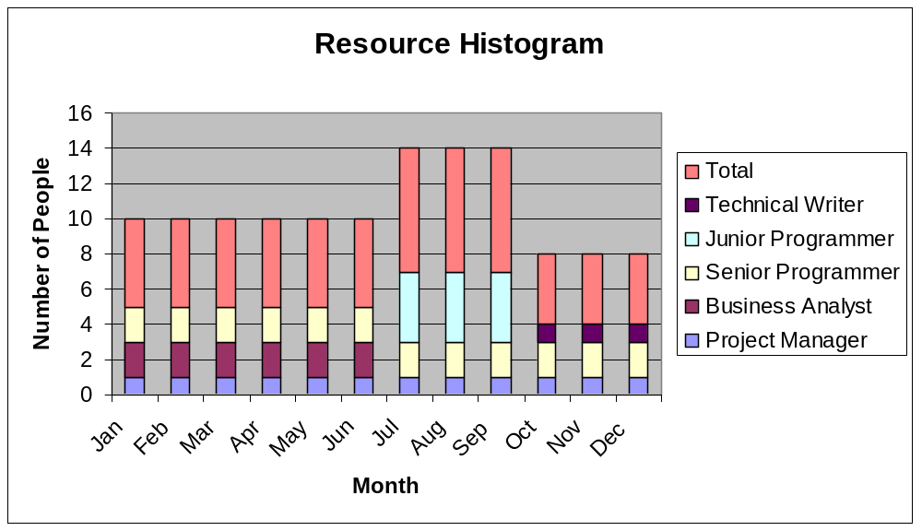
SOLUTION:

Part 2: Enter the five project tasks—project management, systems analysis, systems design, coding and testing, and documentation—and their given durations in Microsoft Project 2002. Assume that one year is fifty-two weeks, six months is twenty-six weeks, and so on. Assume the first three tasks will all start at the same time, that coding and testing can start when systems design is 50 percent completed, and that documentation starts when the coding and testing is completed. Then enter the resource information, as provided in the first paragraph of the Minicase. Instead of entering names for each resource, put the job title. For two people with the same job title, enter business analyst 1 and business analyst 2, for example. Then assign the resources to the appropriate tasks. Print the Gantt chart view of your work on one page when you are finished.
SOLUTION:
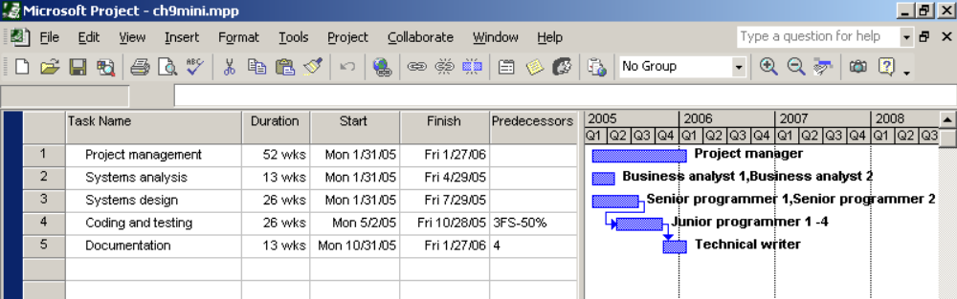

CHAPTER 10
Project Communications Management

Discussion Questions
- Discuss examples of media that poke fun at the communications skills of technical professionals. How does poking fun at technical professionals’ communications skills impact the industry and educational programs?
Dilbert provides a great example of media poking fun at the poor communications skills of technical professionals. Some people argue, however, that this may cause people to shy away from entering a technical profession. Many educational programs still focus primarily on technical courses, although some have realized the need to require more speaking, writing, and listening skills as part of technical degree requirements.
- What are the key components of a project communications plan? How can a stakeholder analysis assist in preparing and implementing parts of this plan?
A project communications plan includes the following components:
- a description of a collection and filing structure for gathering and storing various types of information
- a distribution structure describing what information goes to whom, when it goes, and how it goes
- a format for communicating key project information
- a production schedule for producing the information
- access methods for obtaining the information
- a method for updating the communications management plan as the project progresses and develops
- a stakeholder communications analysis.
A stakeholder analysis shows which stakeholders should get which written communications and in what format. Stakeholders should assist in determining this information by clarifying their specific communications needs.
- Discuss the advantages and disadvantages of different ways to distribute project performance information.
Answers will vary. Electronic communications are often useful when it is important to send information quickly to a large group of people. Face-to-face communications are important for developing relationships and trust with project stakeholders. Formal written communications are important for documenting legal and other crucial information. Verbal communications are very important for many people who prefer to communicate verbally and ask specific questions rather than read information.
- What are some of the ways to create and distribute project performance information?
Project performance information can be distributed verbally, in written format, via e-mail, via the web, formally, and informally.
- Discuss the use of project archives, formal acceptance, and lessons learned as part of administrative closure. Give examples of how each of these items could be used in closing a course on project management.
Project archives are important because they provide an accurate history of a project. Formal acceptance documents the sponsor’s acceptance of the project. Lessons learned provide a means for people to reflect on what they learned working on a project. For closing a course on project management, you can document all information in archives, have the sponsors of class projects formally accept the projects, and have students write lessons learned reports.
- Do you agree with some of the suggestions provided for improving project communications? What other suggestions do you have?
Answers will vary.
- How can software assist in project communications? How can it hurt project communications?
Answers will vary. Software can assist in project communications by helping to create and distribute project information. Project 2002 has several features to enhance project communications, and many other tools are available. Software can hurt project communications if people rely too heavily on using software alone to communicate. It is very important to have meetings and informal communications on projects, too.

Exercises
Answers to all of these exercises will vary. The exercises, and some possible solutions, are provided here for your convenience.

- Create a stakeholder analysis for project communications. Assume your organization has a project to determine employees’ training needs and then provide in-house and external sources for courses in developing communications skills for its employees. Stakeholders could be various levels and types of employees, vendors, the HR Department in charge of the project, and so on. Determine specific stakeholders for the project. List at least one type of project communications for each stakeholder and the format for disseminating information to each. Use Table 10-1 as an example.

SOLUTION: Answers will vary. One possible solution is provided below.

Stakeholders | Document Name | Document Format | Contact Person | Due
Training Manager | Weekly Status Report | E-mail | Bobby Matthews | Start of week
Project Manager | Weekly Status Report | Hard Copy | Brady Lilly | Start of week
HR Management | Monthly Status Report | Hard Copy | Chelsea Homan | 1st of month
Executive Management | Monthly Status Report | Hard Copy | Nick Vanderhyden | 1st of month
IT Director | Monthly Status Report | Intranet | Alexis Jones | 1st of month
Teaching Subcontractor | Implementation of Course Skills | E-mail | Lori Lohman | 8/1/05
Training Subcontractor | Training Plan | Hard Copy | Karen Penkar | 7/1/05

- How many different communications channels does a project team with six people have? How many more channels would there be if the team grew to ten people?
SOLUTION: Number of communications channels = (n(n-1))/2. For 6 people, there would be (6(6-1))/2 =15 communications channels. If the team grew to 10 people, there would be (10(10-1))/2=45 communications channels.
- Review the templates for various project documents provided in this chapter. Pick one of them and apply it to a project of your choice. Make suggestions for improving the template.
- Write a lessons learned report for a project of your choice using Table 10-7 as a guide. Do you think it is important for all project managers and team members to write lessons learned reports? Would you take the time to read them if they were available in your organization?
SOLUTION: Answers will vary. It is important to write a lessons learned report to help yourself and others learn from past projects to do a better job on future projects.
- Research software products that assist in managing large projects. Write a 1-2 page paper summarizing your findings. Include Web sites for software vendors and your opinion of some of the products.
- Write a one- to two-page paper summarizing one of the suggested readings.

MINICASE
You are a member of a project team with twelve members. Several team members work at remote locations, so good virtual communication is crucial. Your team has decided to use a project Web site to store all project documentation and facilitate other communications. You have the task of determining the requirements for the project Web site, researching alternate solutions, making a recommendation, getting team consensus on what to implement, and then implementing the project Web site and acting as the Webmaster.
Part 1: Create a survey that you could use to solicit inputs on requirements for the project Web site from your team members. First, research information on how to design and administer surveys. One potential source of information is www.surveysystem.com. Then create the survey, either using word-processing software or Web-based survey software. Be sure to address a wide range of requirements, such as functionality, cost, security, and maintenance.
Part 2: Your project team has decided to use Web-authoring software to create its project Web site. Using the template provided in Table 10-8, create a project Web site, using your choice of Web-authoring software (for example, Microsoft FrontPage, Macromedia Dreamweaver, Allaire Homesite, or even Microsoft Word). Create the home page and pages for all of the links mentioned in the template. Test the Web pages to make sure they work, and then post them on the project Web site.

SOLUTION: Part 1: Answers will vary. Some of the survey questions might include the following:

On a scale of 1-5 with 1 being the lowest and 5 the highest, rate the following requirements for a project Web site:
- Loads quickly
- Easy to navigate
- All team members can access all information
- Security controls access to and updating of information
- Site can only be accessed by project team
- Site can be accessed by others
- Site includes downloadable template files
- Site is updated daily
- Site is updated weekly
- Site contains links to useful sites

There can also be several open-ended questions concerning security, content, maintenance etc.

Part 2: Solutions should resemble Table 10-8. You can view samples of student project Web sites from my personal Web site at www.kathyschwalbe.com.

CHAPTER 11
Project Risk Management

Discussion Questions

- Discuss the risk utility function and risk preference chart in Figure 11-1. Would you rate yourself as being risk-averse, risk-neutral, or risk-seeking? Give examples of each approach from different aspects of your life, such as your current job, your personal finances, romances, and eating habits.
Answers will vary.
2. What are some questions that should be addressed in a risk management plan?
Answers will vary.

3. Discuss the common sources of risk on information technology projects and suggestions for managing them. Which suggestions do you find most useful? Which do you feel would not work in your organization? Why?
Answers will vary. Tables 10-1 and 10-3 provide some potential risk conditions.
4. What is the difference between using brainstorming and the Delphi technique for risk identification? What are some of the advantages and disadvantages of each approach?
The Delphi technique uses a moderator and keeps the inputs anonymous, while brainstorming has everyone state ideas out in the open. Brainstorming is often faster, easier, and less expensive to do, but the Delphi technique can help avoid bias and political problems.

5. Describe how to use a probability/impact matrix, risk factors, and the Top Ten Risk Item Tracking approaches for performing qualitative risk analysis. How could you use each technique in your organization?
The text gives detailed examples of each technique. See Figure 11-2, Table 11-7, and Figure 11-5 for example. Answers will vary as to how they could be used in students’ organizations.

6. Explain how to use decision trees and Monte Carlo analysis for quantifying risk. Give an example of how you could use each technique on an information technology project.
Answers will vary. Figure 11-4 shows an example of using a decision tree with the EMV calculations. Figure 11-5 shows the results of a Monte Carlo simulation with Project 2002 to help understand schedule risk.

7. Provide examples of risk avoidance, risk acceptance, risk transference, and risk mitigation as responses to risks.
Answers will vary. One example might be that you could use an existing piece of hardware to avoid the risk of waiting for a newer product. You could take your chances that the new product will be available as an example of risk acceptance, and if it’s not, then deal with the problem. You could make a contractor bear the risk of providing the new hardware on time or suffer some type of consequences as an example of risk transference. For risk mitigation, you could lesson the probability of a risk event occurring, such as moving the date back to be more certain the new hardware will be available.

8. List the tools and techniques for performing risk monitoring and control.
Project risk audits, periodic risk reviews, earned value management, technical performance measurement, and additional risk response planning are tools and techniques for risk monitoring and control.

9. How can you use Microsoft Project and Excel to assist in project risk management?
You can use Project 2002 to perform PERT analysis, and you can also use it with add-simulation tools like Risk+. You can also use simulation software with Excel.

10. Why should project managers strive to make their jobs look easy?
If a project runs smoothly, it is usually a sign of good risk management.

Exercises
Answers to all of these exercises will vary. The exercises, and some possible solutions, are provided here for your convenience.
- Suppose your college or organization is considering a new project that would involve developing an information system for all employees and students/customers to access and maintain their own human resource-related information, such as address, marital status, tax information, and so on. The main benefits of the system would be a reduction in human resources personnel and more accurate information. For example, if an employee, student, or customer had a new telephone number or e-mail address, he or she would be responsible for entering the new data in the new system. The new system would also allow employees to change their tax withholdings or pension plan contributions. Identify five potential risks for this new project. Provide a detailed description of each risk and propose strategies for mitigating each risk.
SOLUTION: Answers will vary. Potential risks might include employee resistance to the new system; opposition to the new system from the human resources department (since some of their people might lose their jobs); technical risks in developing or implementing the system; operational risks if people do not use the system or update their information; and security risks if users provide false information or give their passwords to others. Strategies for mitigating risks will vary.
- Review a project risk management plan. Did the organization do a good job of answering the questions that should be addressed in a risk management plan? If you cannot find a risk management plan, write one of your own for an information technology project your organization is considering.
- Research risk management software. Are many products available? What are the main advantages of using them? What are the main disadvantages? Write a paper discussing your findings and include at least three references.
SOLUTION: Several risk management software products are available. Answers will vary concerning what products are available and what their advantages and disadvantages are. Risk+ for Project 2002 is a popular one, as is Crystal Ball, an add-on for Excel.
- Suppose your organization is deciding which of four projects to bid on. Information on each is in the Table below. Assume that all up-front investments are not recovered, so they are shown as negative profits. Draw a diagram and calculate the EMV for each project. Write a few paragraphs explaining on which projects you would bid. Be sure to use the EMV information and your personal risk tolerance to justify your answer.
SOLUTION: The table below shows the calculations for EMV. Project 1 has the highest EMV at $35,000. Answers will vary on which project to select based on risk tolerance.
 | Change of Winning | Estimated Profits/Losses | Product
Project 1 | 50% | $120,000 | $60,000
 | 50% | ($50,000) | ($25,000)
 |  | EMV | $35,000
Project 2 | 30% | $100,000 | $30,000
 | 40% | $50,000 | $20,000
 | 30% | ($60,000) | ($18,000)
 |  | EMV | $32,000
Project 3 | 70% | $20,000 | $14,000
 | 30% | ($5,000) | ($1,500)
 |  | EMV | $12,500
Project 4 | 30% | $40,000 | $12,000
 | 30% | $30,000 | $9,000
 | 20% | $20,000 | $4,000
 | 20% | ($50,000) | ($10,000)
 |  | EMV | $15,000

- Find an example of a company that took a big risk on an information technology project and succeeded. In addition, find an example of a company that took a big risk and failed. Summarize each project and situation. Did anything besides luck make a difference between success and failure?
ANSWER: Answers will vary. Examples could be found at many large IT companies. Bill Gates dropped out of Harvard to take the risk of starting his own business, which succeeded beyond anyone's expectations. Steve Jobs took a risk on the Apple Lisa, which failed in the marketplace. Most people would argue that hard work and good planning and execution have more to do with success than luck.

MINICASE
Your college or organization implemented a project, described in Exercise 1, to provide an information system for all employees, students, and customers, allowing them to access and maintain their own human resources-related information, such as address, marital status, and tax information. Many problems arose after implementation. You knew there was a potential risk that people would not use the system, and you have discovered that less than half of all potential users are using it. This low usage has caused bottlenecks in the human resources department, because the staff was reduced to pay for the new system. You also anticipated some security problems if users shared their passwords with friends or family members, but now your organization is facing potential litigation.
Part 1: List four alternatives to address the problem of eligible users not using the system. Describe each option in detail. Include estimates of how long it would take to implement, how much it would cost, and how effective it would be. Also, list at least one potential secondary risk that might arise after implementing each option.
SOLUTION: Answers will vary. Some potential alternatives to addressing the problem of eligible users not using the system include the following:
- Offer a reward for new users, such as a free meal in the company cafeteria or a gift certificate of some sort. A residual risk may be that employees want rewards for similar new systems, and costs could be high.
- Create a policy to penalize people who do not use the new system. For example, each division boss could get a list of people not using the system and post their names somewhere for people to see. Another penalty might be charging employees for using HR staff members’ time to do what they can do with the new system. A residual risk could be decreased employee morale.
- Promote the new system more. Some people may not be using the new system because they don’t know enough about it or need training on how to use it. A residual risk might be that people are taking up too much time and money promoting the new system or training others on how to use it.
Answers on how long each alternative would take, what it would cost, potential residual risks, etc. will vary.
Part 2: You have confirmed the fact that the new system has several security problems, including users sharing their passwords with friends or family members. This behavior has resulted in several pranks, such as entries of bogus names and addresses. More serious compromises of security have caused financial and legal problems. One woman is threatening to sue the organization because someone gathered a list of e-mail addresses from the system and sent a mass mailing of a multilevel marketing spam. Write a one- to two-page policy statement that your organization could implement to transfer the risk of these inappropriate uses of the system to the users of the system or to a third party.
SOLUTION: Answers will vary. The policy statement should clearly state security and usage of the new system and how risk of inappropriate risk will be transferred to a third party. For example, if someone is caught giving out their password to someone else, that employee could be fired or penalized in some other way. The company might hire a security firm that would be responsible for preventing severe security breaches.
CHAPTER 12
Project Procurement Management

Discussion Questions
- List five reasons why organizations outsource. Why is there a growing trend in outsourcing, especially in the government?
Organizations outsource to reduce both fixed and recurrent costs, to allow the client organization to focus on its core business, to access skills and technologies, to provide flexibility, and to increase accountability. More organizations are using outsourcing for the above reasons. The government does not have the specialized skills needed to meet the growing need to IT projects, so it plans to outsource even more.
- Explain the make-or-buy process and how to perform the financial calculations involved in the process. What are the main types of contracts if you do decide to outsource? What are the advantages and disadvantages of each?
In a make-or-buy analysis, you set up an equation so that the cost to make something is equal to the cost to buy it. See pp. 432-433 for a detailed example. The types of contracts are fixed price, cost-reimbursable, hybrids like time and materials, or unit price contracts. See pages 433-436 for more information on each type of contract.
- Do you think many information technology professionals have experience writing RFPs and evaluating proposals for information technology projects? What skills would be useful for these tasks?
Answers will vary. Good writing and research skills would be useful for writing and evaluating RFPs., as would knowledge of the products and services being outsourced.
- What is involved in the solicitation process? How do organizations decide whom to send RFPs or RFQs?
Solicitation involves obtaining proposals or bids from prospective suppliers. Organizations can send RFPs or RFQs to one preferred supplier, several suppliers, or out for an open bid, depending on their needs and policies.
- How can organizations use a weighted decision matrix to evaluate proposals as part of source selection?
See Figures 12-5 and 12-6 for examples of using a weighted decision matrix to evaluate proposals.
- What are two suggestions for ensuring adequate change control on projects that involve outside contracts?
Answers will vary. It’s important to review all changes and put them in writing.
- How can software assist in procuring goods and services? What is e-procurement software?
Many types of software assist in procurement, including word-processing, spreadsheet, databases, and the Internet. E-procurement software is software that handles various procurement functions electronically. For example, many companies now auction off items or handle bids electronically.

EXERCISES
Answers to all of these exercises will vary. The exercises, and some possible solutions, are provided here for your convenience.
- Research information on information technology outsourcing. Find at least two articles and summarize them. Answer the following questions:
a. What are the main types of goods and services being outsourced?
b. What are some of the largest companies that provide information technology outsourcing services?
c. Why is outsourcing growing so rapidly?
d. Have most organizations benefited from outsourcing? Why or why not?
SOLUTION: Answers will vary based on the references used.
- Interview someone who was involved in an information technology procurement process and have him or her explain the process that was followed. Write a paper describing the procurement and any lessons learned by the organization.
SOLUTION: Answers will vary. Be sure students prepare for this interview and document it well. They should also send a copy of their paper to the person interviewed.
- Suppose your company is trying to decide whether it should buy special equipment to prepare some of its high-quality publications itself or lease the equipment from another company. Suppose leasing the equipment costs $240 per day. If you decide to purchase the equipment, the initial investment is $6,800, and operations will cost $70 per day. After how many days will the lease cost be the same as the purchase cost for the equipment? Assume your company would only use this equipment for thirty days. Should your company buy the equipment or lease it?
SOLUTION: Let d = the number of days you need the equipment. Set up an equation where the lease equals the buy as follows:
$6,800 + $70d = $240d
$6,800 = $170d
d = 40
Therefore, after 40 days, the lease cost will be the same as the purchase cost. If you need the equipment for only thirty days, you should lease it.
- Find an example of a contract for information technology services. Analyze the key features of the contract. What type of contract was used and why? Review the language and clauses in the contract. What are some of the key clauses? List questions you have about the contract and try to get answers from someone familiar with the contract.
SOLUTION: Answers will vary. Many contracts are still difficult to interpret.
- Draft an RFP for an information technology project to provide laptops for all students, faculty, and staff at your college or university. Use the outline provided in Figure 12-4. List the assumptions you made in preparing the RFP.
SOLUTION: Answers will vary. Writing an RFP is much more difficult than most people think.
- Draft the source selection criteria that might be used for evaluating proposals for providing laptops for all students, faculty, and staff at your college or university. Use Figure 12-6 as a guide. Include at least five criteria, and make the total scores add up to 100. Write a paper justifying the criteria and scores.
SOLUTION: Answers will vary. Be sure the criteria include non-technical areas.

MINICASE
Your company is reevaluating its policies concerning cellular telephones, and its approach to providing cellular telephone services to its employees. All 1500 consultants and salespeople are authorized to use their choice of cellular telephone services with unlimited calling privileges, and these expenses have increased dramatically. Several employees are using new features such as Internet access via their cell phones. To provide for new capabilities and to benefit from a corporate discount, your company is issuing a request for proposals to provide cellular telephone services for the entire company.
Part 1: Research at least three companies that provide cellular telephone services. Write a paragraph describing the purpose of the RFP that your company plans to issue and another paragraph describing the basic requirements. Write these paragraphs so that at least three potential suppliers would meet the basic requirements. Then develop a list of criteria that your company could use for evaluating a cellular telephone services supplier. Include at least ten criteria, and assign weights to each criterion to total 100 percent. Create a spreadsheet to accompany your proposal evaluation sheet, using Figure 12-5 as a guide.
SOLUTION: Part 1. Answers will vary based on the market for cellular telephone service. Large players in the market in 2001 include MCI, Sprint, and Verizon. Criteria for evaluating the supplier could include market share, price for phones, price for service, number of local minutes included, number of long-distance minutes included, corporate discounts, total estimated price for 1500 users, use in foreign countries, past performance, references, phone display size, phone size, and so on.
Part 2: You want to include special clauses in your contract for cellular telephone services to provide for the following:
- To ensure that your company is getting the best rates possible. Assume that you will commit to a one-year renewable contract and a minimum of 1000 cell phones.
- To be able to make special features, such as Internet access, available to only certain employees
- To receive special reports identifying employees who have excessive charges
Write a paragraph for each of these clauses, using appropriate contractual language.
SOLUTION: The wording of clauses will vary. Possible wording is listed below:
- This contract provides a minimum commitment of one-year service for 1,000 cell phones. The contract is renewable on an annual basis. To ensure competitive pricing, the supplier will provide the same or lower prices for this contract as any other similar contract awarded during the time period of this contract.
- The purchaser will have the right and ability to limit special features, such as Internet access, to certain employees. The supplier will work with the purchaser to administer the availability and tracking of usage by individual and group of users under this contract.
- The supplier will provide access to special reports, including but not limited to reports noting charges over a specified amount for specific services to specific individuals or groups. The supplier will work with the purchase to create and provide access to these reports.

APPENDIX A

Guide to Using Microsoft Project 2002

Discussion Questions:
1. What are some of the main differences between Project 2002 and previous versions of Microsoft Project?
The biggest difference between Project 2002 and previous versions are the separate versions of Project for individual versus enterprise use. Other differences are listed on pages 457-459.
2. How do you use Project 2002 to create a WBS hierarchy?
When you enter the tasks, you indent tasks to show the WBS hierarchy.
3. Summarize how you use Project 2002 to assist in time management. How do you enter durations, link tasks, and view critical path information?
You enter durations in the duration column. There are several ways to link tasks, such as clicking the icon, enter a predecessor in that column, or using the Gantt chart. You can view critical path information by viewing the network diagram, running the critical tasks report, filtering to show critical tasks, or changing the color of critical task items on the Gantt chart.
4. How can Project 2002 assist you in project cost management? How do you enter fixed costs? How do you enter resources and assign them to tasks? How can you view earned value information?
You can enter various types of costs into Project 2002. You can enter fixed costs using the cost table view. There are several ways to assign resources, as described in that section. You can view earned value information by viewing the earned value table.
5. Briefly describe how to change resource calendars, view resource histograms, and level resources.
See detailed descriptions of these features in the text on pages 523-531.
6. Summarize different ways to communicate information with Project 2002. How do you link to other files from within your Project 2002 file? How can you use templates and share information on the Web?
Table A-5 on p. 532 lists important features of Project 2002. You can insert hyperlinks to other files from within Project 2002. You can use templates to provide a common format for various project documents. You can also convert Project 2002 information into html or download Project 2002 files on the Web. The enterprise version of Project 2002 includes many more Web features.

Exercises:
Answers to the exercises will vary, especially the dates. Some possible solutions are provided here. Solution files are provided on the Instructor’s Resource CD-Rom. Note: If you used the second edition of this text, you’ll notice that the exercises in Appendix A are the same, as are the solutions.

Exercise A-1: Web Site Development
A possible solution, including the WBS, duration estimates, cost information, and human resource information for the project is provided in the file 3eExA-1.mpp, included on the Instructor’s Resource CD.

Below is a possible Gantt chart for Exercise A-1 showing the WBS, duration estimates, predecessors, and resource assignments. Note that the project takes about four months, starting on 1/3/02 and ending 4/25/02. Dates will obviously vary.

Gantt chart for Exercise A-1

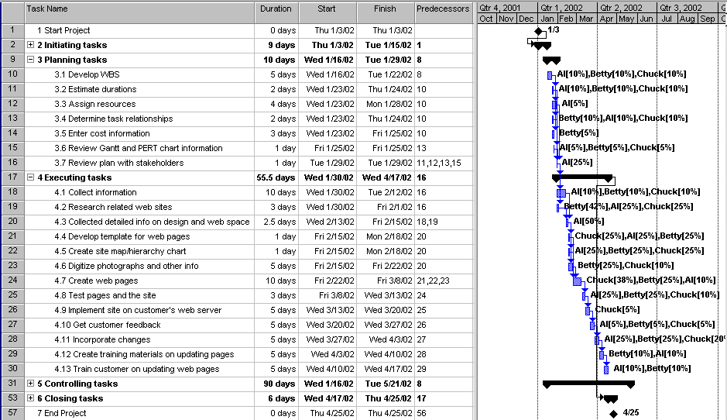
To run the budget report, open the file, then select Reports from the View menu. Double-click on Costs, and then double-click on Budget.

Below is the budget report based on the file 3eExA-1.mpp. Answers will vary, but the total amount should be between $4,000 and $5,000 based on 3 people working an average of 5 hours per week for 4 months at $20 per hour. Determining the resource allocations is probably the hardest part of this exercise. After entering initial resource estimates, you can see more clearly how many hours each person is assigned to each task by using the Resource Usage view. You can also adjust the hours in this view and then run the budget report until the numbers seem reasonable.

Budget report for Exercise A-1
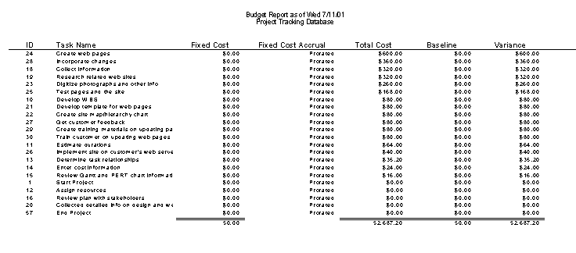

To see the Resource Usage View for this file, click the Resource Usage View on the View bar.

To run the To-do list report, select Reports from the View menu, double-click Assignments, then double-click on the To-do List report, and run it for each person on the project.

To create the Who Does What Report HTML document, select Save as HTML from the File menu, name the file, select Who Does What Report from the Import/export map list, then click the Save button.

Exercise A-2: Software Training Program
A possible solution, including the WBS, duration estimates, cost information, and human resource information for the project is provided in the file 3eExA-2.mpp, found on the Instructor’s Resource CD.

Below is a possible Gantt chart for Exercise A-2 showing the WBS, duration estimates, and predecessors. Note that the project takes about six months, starting on 1/3/02 and ending 5/30/02 in this example. The resources and some fixed cost have been entered in this file, but allocations have not been made.

Gantt chart for Exercise A-2

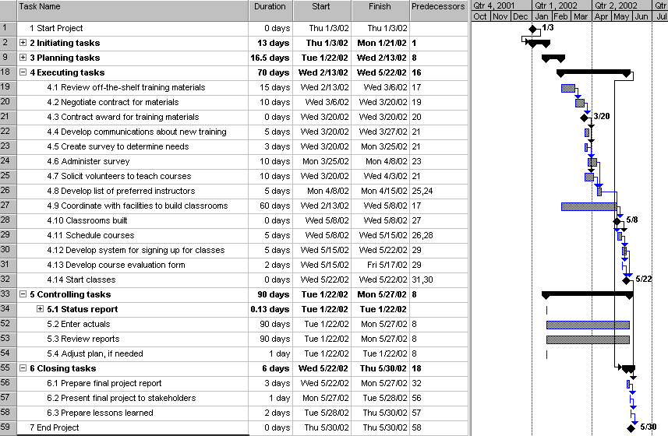
You can view the resource sheet, network diagram, schedule table, and run the desired reports by opening the file and using those views and reports. Answers will vary based on how students created the WBS, estimated durations and dependencies, and assigned resources.

Exercise A-3. Project Tracking Database
A possible solution, including the WBS, duration estimates, cost information, and human resource information for the project is provided in the file 3eExA-3.mpp, found on the Instructor’s Resource CD.

Below is a possible Gantt chart for Exercise A-3 showing the WBS, duration estimates, and predecessors. Note that the project takes about six months, starting on 6/2/02 and ending 11/13/02. The total budget based on this file is about $53,000.

Gantt chart for Exercise A-3

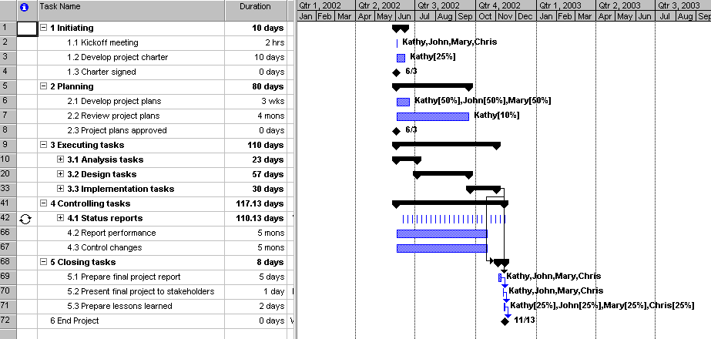
Open the file to see all of the tasks, predecessors, resource information, and so on. You can also run the reports after opening the file. Below is the Top Level Tasks report based on this file. To run this report, select Reports from the View menu, then double-click on Overview, then double-click on Top Level Tasks.

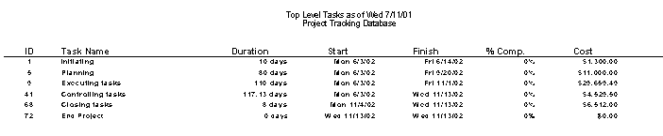
Exercise A-4: Real Project Application
Answers will vary based on the projects.

APPENDIX B
Advice for the PMP Exam and Related Certifications

Discussion Questions:
- What is PMP certification, and why do you think the number of people earning it has grown so much in the past ten years?
The Project Management Institute (PMI) manages the Project Management Professional (PMP) certification program. More and more people continue to earn this certification to help meet the demand for professional project managers throughout the world.
- What do you need to do before you can take the PMP exam? What is the exam itself like? What do you need to do to maintain PMP certification?
In order to take the PMP exam, you need to have experience working on projects, complete 35 hours of formal education, agree to the PMP certificant and candidate agreement, and pay the appropriate fee. The exam itself consists of 200 choice multiple-choice questions. To maintain certification, you need to document 60 professional development units every three years.
- Briefly describe project management certification programs other than the PMP certification.
CompTIA manages the IT Project+ certification, which does not have any prerequisites or renewal requirements. Other programs include PMI’s CAQs, Microsoft’s MOS program, the International Project Management Association programs, and the Certified IT Project Manager program in Singapore.
- What is the difference between conceptual, application, and evaluative questions? Which project management process groups have the most questions on the PMP exam?
Conceptual questions test your understanding of key terms and concepts; application questions ask you to apply techniques to specific problems; and evaluative questions provide situations for you to analyze. 23.5 percent of the PMP questions are from the planning process group, 23.5 percent are from the executing process group, and 23 percent are from the controlling process group.
- If you plan to take the PMP exam soon, what should you do to prepare?
If you plan to take the PMP exam within six months, you should apply to take the exam and schedule a time to take it. You should also study materials like this textbook, and perhaps order other materials with sample exam questions.
- Which tips for taking the PMP exam do you think would be most helpful for you?
Answers will vary.

Exercises:
Answers to all of the exercises will vary. They are provided below for your convenience.
1. Go to PMI's Web site and review the information about taking the PMP exam. Write a one- to two-page paper summarizing what you found.
2. Go to CompTIA's Web site and review the information about taking the ITProject+ exam. Write a one- to two-page paper summarizing what you found.
3. Download the sample PMP questions and answers from PMI's Web site. Take the sample test, and then score your results. Summarize how you did and areas you would need to study before you could take the PMP exam.
4. Interview someone who has PMP or ITProject+ certification. Ask him or her why he or she earned the PMP certification and how it has affected his or her career. Write your finings in a one- to two-page paper.
5. Do an Internet search on earning PMP certification. Be sure to search for Yahoo Groups related to this topic. What are some of the options you found to help people prepare for the exam? If you were to take the exam, what do you think you would do to help study for it? Do you think you would need additional information beyond what is in this text to help you pass? Write a one- to two-page paper describing your findings and opinions.
6. Read a recent issue of PMI’s PM Network magazine. You can order a copy from PMI’s Web site, or contact someone from a local PMI chapter to obtain a copy. Summarize all of the ads you find in the magazine related to earning PMP certification in a one-to two-page paper. Also, include your opinion on which ad, course, books, CD-ROMs, etc. appeals to you the most.
APPENDIX C
Running Cases

Running Case 1: Recreation and Wellness Intranet Project
This running case continues the Minicase scenarios from Chapters 2 and 3. It most closely resembles the JWD Consulting case study presented in Chapter 3.

Part 1: Initiating
Scenario
Manage Your Health, Inc. (MYH) is a Fortune 500 company that provides a variety of health care services across the globe. MYH has more than 20,000 full-time employees and more than 5,000 part-time employees. MYH recently updated its strategic plan, and key goals include reducing internal costs, increasing cross selling of products, and exploiting new Web-based technologies to help employees, customers, and suppliers work together to improve the development and delivery of its health care products and services. Below are some ideas the information technology department has developed for supporting these strategic goals:
1. Recreation and Wellness Intranet Project: Provide an application on the current Intranet to help employees improve their health. A recent study found that MYH, Inc. pays 20 percent more than the industry average for employee health care premiums, primarily due to the poor health of its employees. You believe that this application will help improve employee health within one year of its roll-out so that you can negotiate lower premiums, saving about $30/employee/year for full-time employees over the next four years. This application would include the following capabilities:
- Allow employees to register for company-sponsored recreational programs, such as soccer, softball, bowling, jogging, walking, and other sports
- Allow employees to register for company-sponsored classes and programs to help them manage their weight, reduce stress, stop smoking, and manage other health-related issues
- Track data on employee involvement in these recreational and health-management programs
- Offer incentives for people to join the programs and do well in them (i.e., incentives for achieving weight goals, winning sports team competitions, etc.)
2. Health Coverage Costs Business Model: Develop an application to track employee health care expenses and company health care costs. Health care premiums continue to increase, and the company has changed insurance carriers several times in the past ten years. This application should allow business modeling of various scenarios as well as tracking and analyzing current and past employee health care expenses and company health care costs. This application must be secure and run on the current intranet so several managers and analysts could access it and download selective data for further analysis. The new application must also import data from the current systems that track employee expenses submitted to the company and the company’s costs to our insurance provider. You believe that having this data will help you revise policies concerning employee contributions to health care premiums and help you negotiate for lower premiums with insurance companies. You estimate that this application would save your company about $20/employee/year for full-time employees over the next four years and cost about $100,000 to develop.
3. Cross-Selling System: Develop an application to improve cross-selling to current customers. The current sales management system has separate sections for major product/service categories and different sales representatives based on those products and services. You see great opportunities to increase sales to current customers by providing them discounts when they purchase multiple products/services. You estimate that this system would increase profits by $1 million each year for the next three years and cost about $800,000 each year for development and maintenance.
4. Web-Enhanced Communications System: Develop a Web-based application to improve development and delivery of products and services. There are currently several incompatible systems related to the development and delivery of products and services to customers. This application would allow customers and suppliers to provide suggestions, enter orders, view the status and history of orders, and use electronic commerce capabilities to purchase and sell their products. You estimate that this system would save your company about $2 million each year for three years after implementation. You estimate it will take one year and $3 million to develop and require 20 percent of development costs each year to maintain.

Tasks
1. Summarize each of the above-proposed projects in a simple table format suitable for presentation to top management. Include the name for each project, identify how each one supports business strategies, assess the potential financial benefits and other benefits of each project, and provide your initial assessment of the value of each project. Write your results in a one- to two-page memo to top management, including appropriate back-up information and calculations.
SOLUTION: Answers will vary. Below is a table summarizing each project. The memo information will vary.
Project Name | Business Strategy | Financial Benefits | Other Benefits | Initial Assessment
1. Recreation & Wellness Intranet | reducing costs | $2.4M over 4 years | improve heath | high potential, upfront
 |  | less costs | and productivity, | costs and need to
 |  |  | lower premiums | persuade people to
 |  |  |  | join teams/programs
2. Health Coverage | reducing costs | $1.6M over 4 years | negotiate lower | high potential, cost $100K
Business Model |  | less costs | premiums | upfront
3. Cross-Selling System | Increase cross selling | $3M over 3 years | increased sales, | medium, cost $800K/year
 |  | less costs | better customer
 |  |  | service
4. Web-Enhanced Comm. System | exploit Web | $6M over 3 years | improve comm. | low, cost $3M to develop
 |  |  |  | and $600K/year to maintain

2. Prepare a weighted decision matrix using the template provided in Appendix D to evaluate these four projects. Develop at least four criteria, assign weights to each criterion, assign scores, and then calculate the weighted scores. Print the spreadsheet and bar chart with the results. Also write a one-page paper describing this weighted decision matrix and what the results show.
SOLUTION: Answers will vary. Below is one potential weighted decision matrix. Note that Projects 1 and 2 look most promising.
Weighted Scoring Model for MYH Inc.
Created by: | Bobby S. |  | Date: | 6/17/2005
Criteria | Weight | Project 1 | Project 2 | Project 3 | Project 4
tie to business strategy | 10% | 90 | 90 | 90 | 90
upfront costs | 25% | 70 | 80 | 20 | 10
potential net savings | 25% | 90 | 70 | 50 | 20
realistic technology | 15% | 90 | 70 | 60 | 50
in-house expertise | 10% | 90 | 80 | 60 | 50
potential resistance | 15% | 50 | 90 | 90 | 50
Weighted Project Scores | 100% | 79 | 78.5 | 55 | 36.5

3. Assume that you have been assigned to work on the Recreation and Wellness Intranet Project described above. You are part of a team to help select the project manager for this project. Write a one- to two-page job description for this person, including a description of job duties, required experience and education, and desired skills.
SOLUTION: Answers will vary. Students should look at real job listings to get ideas.
4. Prepare a business case for the Recreation and Wellness Intranet Project. Assume the project will take six months to complete and cost about $200,000. Use the business case template provided in Appendix D.
SOLUTION: Below is one potential solution. Note the strong financial projections. Payback occurs in less than a year, the ROI is 444%, and the NPV is over $1.6 million.
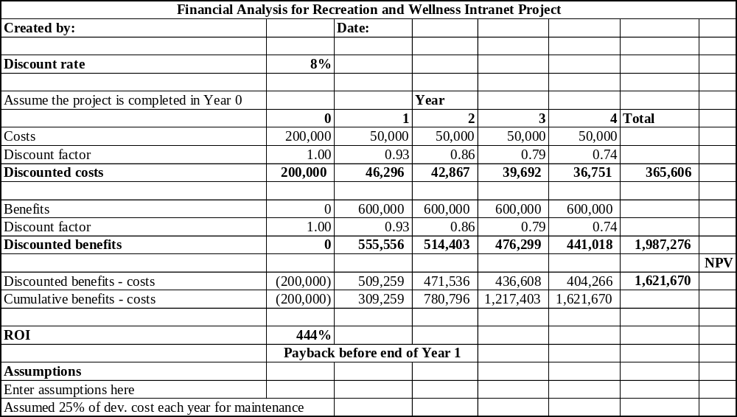
5. Prepare a project charter for the Recreation and Wellness Intranet Project. Assume the project will take six months to complete and cost about $200,000. Use the project charter template provided in Appendix D.
SOLUTION: Below is one potential solution.
Project Charter

Project Title: MYH Recreation and Wellness Intranet Project
Project Start Date: 2/1/05 Projected Finish Date: 8/1/05
Budget Information: $200,000 is the estimated project cost

Project Manager: Tony Prince, tonyprince@myh.com, (662)558-4888
Project Objectives: By providing this application on our current Intranet, we can help employees improve their health, resulting in lower health care costs and improved productivity. The system will allow employees to register for company-sponsored recreational programs and wellness classes, track data on involvement in these programs, and offer incentives for people to join the programs and do well in them.

Approach:
- Select the project team
- Determine project requirements
- Develop the application following corporate standards and using a prototyping approach
- Use good testing procedures
- Provide training and develop support process
Roles and Responsibilities
Role | Name | Organization/  Position | Contact Information
Project sponsor | Manager X | MYH, senior manager | managerx@myh.com
Project manager | Tony Prince | MYH, manager | tonyprince@myh.com
Project team members | You, Patrick, Nancy, Bonnie, Cassandra | MYH IT, HR, finance
CIO | Manager Y | Senior manager
CFO | Manager Z | Senior manager

Sign-off: (Signatures of all above stakeholders. Can sign by their names in table above.)

Comments: (Handwritten or typed comments from above stakeholders, if applicable)

Part 2: Planning
Scenario
Managers at MYH selected Tony Prince as the project manager for the Recreation and Wellness Intranet Project. Tony had previous project management and systems analysis experience within the company, and he was an avid sports enthusiast. Tony was starting to put the project team together. Team members so far included you, a programmer/analyst and aspiring project manager, Patrick, a network specialist, Nancy, a business analyst, and Bonnie, another programmer/analyst. Tony also had a few people from other departments supporting the project, such as James, from human resources, and Cassandra from finance. Tony knew he would have to develop a survey to solicit input from all employees about this new system and make sure it was very user-friendly.

Tasks
1. Develop a team contract for this project. Use the template provided in Appendix D as a guide. Also, look at the examples of project charters in Chapters 3 and 5.
SOLUTION: The team contract should look similar to the one on p. 82 of the text.
2. Prepare a stakeholder analysis for this project, using the template provided in Appendix D and example in Chapter 4 as guides. Be creative in making up information about stakeholders.
SOLUTION: The stakeholder analysis information will vary, but the format should be similar to the one found on p. 116.
3. Develop a scope statement for the project. Use the template provided in Appendix D and the example in Chapter 3 as guides. Be as specific as possible in describing product characteristics and requirements, as well as product deliverables.
SOLUTION: Answers will vary, but the structure should be similar to the one on pages 83-85. Be sure students clearly describe all of the deliverables.
4. Develop a work breakdown structure (WBS) for the project. Break down the work to level 2 or level 3, as appropriate. Use the template in Appendix D and samples in Chapters 3 and 5 as guides. Print the WBS in list form as a Word file. Be sure the WBS is based on the project charter, scope statement, and other relevant information.
SOLUTION: Answers will vary. Since it is an intranet application, the WBS could be similar to several of those found in chapter 5, such as the one found on p. 161.
5. Use the WBS you developed in number 4 above to create a Gantt chart and network diagram in Project 2002 for the project. Estimate task durations and enter dependencies, as appropriate. Also include several milestones. Remember that your schedule goal for the project is six months. Print the Gantt chart and network diagram.
SOLUTION: Answers will vary. Below is part of one solution. You can access this file, case1_task2-5.mpp from the Instructor’s CD.
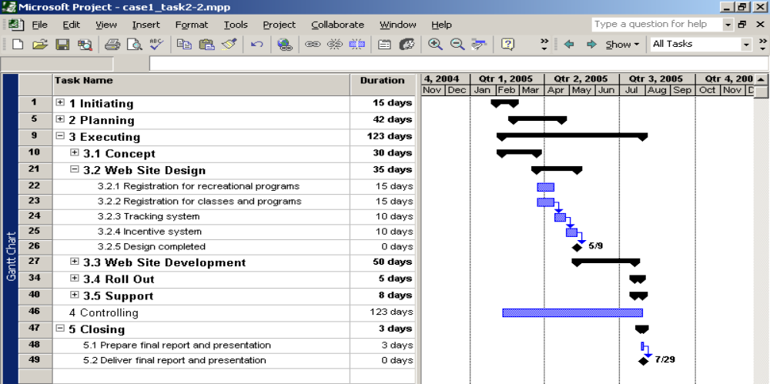
6. Assign resources to the tasks in the Gantt chart using Project 2002. See Appendix A for instructions on setting up a resource sheet and assigning resources. Assume that Tony works an average of twenty hours per week on the project and earns $100 per hour and the other team members and support staff earn $60 per hour. Assume no one is paid overtime. Assume team members can work up to full time on the project and support staff can work up to ten hours per week. Remember that your budget for the six-month project is $200,000. Assume all costs are for internal labor. Print the cash flow report showing costs each month. Also print the resource usage report showing the hours each person is assigned to work on each task each week.
SOLUTION: Answers will vary based on how the WBS is set up and how many hours people are assigned. Be careful to make sure the resource assignments do not change the durations, and students should do their best to make the total project cost equal about $200,000 over six months. It can be difficult to make the assignments as you intend them to be and have the costs add up to what you’d like.
7. Create a probability/impact matrix and list of prioritized risks for the project. Include at least ten risks. Use the templates in Appendix D and examples in Chapters 3 and 11.
SOLUTION: Answers will vary. Potential risks might include a lack of management support, lack of user inputs, disagreements on programs to offer, personality conflicts, and so on.

Part 3: Executing
Scenario
Tony Prince and the project team have run into a few challenges in executing the Recreation and Wellness Intranet Project. It has been two months since the project started. The company recently fired its Chief Financial Officer (CFO), and the new CFO likes to keep a very close eye on all projects and expenditures that she considers mission-critical, including your project. She is a naturally slim woman but also not very athletic, so she questions the potential savings projected from your project. In addition, James, the person supporting your project from the human resources area, has not been very helpful. Your project team thought there were a lot of acronyms and terms unique to the information technology area, but you're having a hard time understanding several of James’s suggestions because he uses a lot of human resources and wellness terminology. The same is true for Cassandra, your support person from the finance area. She also voiced her frustration at the project team meetings, which seemed to focus excessively on technical details with little or no discussion of financial topics. You are also having some difficulties working with Bonnie, the other main programmer on this project. She insists that you document and study everything very closely before writing any code. You prefer to develop screens and other ideas quickly to get user feedback. You also did not receive much response from the survey you sent to all employees asking about their interest in this new system and suggestions for what features it should have. The project team’s mentality is to plow ahead to make the schedule, but you wonder if the system will be of value if you do not get more support for it.

Tasks
Answers to all of the executing tasks will vary. They are listed below for your information.
1. Develop a few prototype screens for the Recreation and Wellness Intranet. Include a home page and at least two other screens. Use any software to create the prototype.
2. Develop a project Web site for the Recreation and Wellness Intranet Project. Use the sample template from Chapter 10, and include links to all project documents and the prototype screens created in step 1 above. Post the pages on the Web site.
3. Your project manager, Tony, has to give a short presentation at a management review meeting with the new CFO, the Chief Information Officer (CIO), and several other top managers at MYH. Tony asked you to help him prepare the presentation. He needed to make it 5-10 minutes long. Since the CFO did not know much about this or other projects, the main intent of the meeting was to inform everyone about the project its progress. Prepare five to ten slides that Tony could use as part of his presentation.
4. The CFO has asked all project teams to submit weekly milestone reports directly to her. Prepare a milestone report for the project based on information in your Gantt chart. Assume you are two months into your project. Add additional milestones, if needed, to make the report more meaningful. Use the milestone report template in Appendix D and the sample from Chapter 3.
5. Develop an agenda for a project team meeting to work through some of the challenges you are facing in executing the project so far. Write a one- to two-page paper with several alternatives for addressing these challenges.
6. After the management review meeting described in step 1 above, management has decided to change the scope of the project. In addition to providing information for employees related to recreational activities and wellness programs sponsored by your company, the system should also include information about similar programs offered through a health club chain MYH recently acquired and all similar community-sponsored programs within twenty miles of MYH. You estimate this will increase the number of sports teams, wellness programs, and so on by a factor of ten to twenty. Management has asked your project team to provide new schedule and cost estimates. They are willing to spend more money and suggest outsourcing some of the work, and they would like to see the system operational within nine months from now. Document all of the planning information that you will need to change based on this information. Estimate how many hours it will take to update all the plans.
7. Develop a detailed list of assumptions and questions that the project team has related to the new scope of the project. Document the information in a one- to two-page memo to management.

Part 4: Controlling
Scenario
The project team was pretty much on schedule until management changed the scope of the project. You are working on updating all of your project plans. You decided to outsource much of the work related to user requirements, user interface design, and collecting information about similar programs offered through the health club chain MYH recently acquired and all similar community-sponsored programs within twenty miles from the company. The CFO strongly recommended a consulting firm she had worked with in the past, and she personally helped write the contract for its work. She is also monitoring the project team’s project very closely.

Tasks
Answers to all of the controlling tasks will vary. They are listed below for your information.
1. Review the Gantt chart you created in part 2, and then update it based on the new scope of the project. Assume that everything was going as planned for the first two months of the project, and then you created a new baseline after management changed the project scope.
2. Update the project charter and scope statement. Briefly describe other plans you have created so far that you think you should update.
3. Assume that the contract and statement of work (SOW) for the outsourced work is complete except for information on controlling—specifically, how the supplier will report its progress information. Write a few paragraphs describing what information you want to see to make sure the supplier is doing a good job.
4. Review the templates in Appendix D and on the companion Web site for this text (www.course.com/mis/schwalbe) related to controlling. Decide which ones you want the supplier to use for its work and include instructions for using them.
5. Update your list of prioritized risks. Write a one- to two-page paper explaining the new risk information.

Part 5: Closing
Scenario
It has been almost nine months since the project scope changed. You did roll out the Recreation and Wellness Intranet last week, and so far the user response has been very positive. The CIO wants to know what will be involved in maintaining the system after the project is over. Your final project presentation to top management is next week. You did meet your schedule goal, and the final cost for the whole system was about $500,000. Top management is pleased with the results, even though it cost about $100,000 more than planned.

Tasks
Answers to all of the closing tasks will vary. They are listed below for your information.
1. Prepare a short presentation with ten to fifteen slides that Tony could use at the final project presentation. Assume that Tony has fifteen to twenty minutes to give the presentation.
2. Prepare a lessons-learned report for the entire project. Include input from all stakeholders in summarizing the lessons learned. Use the template provided in Appendix D, and be creative in your response.
3. Prepare a final project report, using information provided in the template for final project documentation in Appendix D.
4. Write a one- to two-page transition report describing what will be involved in maintaining the new system. Look for templates for transition reports on the companion Web site or samples of actual transition reports available on the Internet.
5. Update the project Web site so that it includes all final project and product deliverables.

RUNNING Case 2: six sigma project
This running case will help you learn more about Six Sigma as well as project management. It also includes the use of many templates provided in Appendix D.

Part 1: Initiating
Scenario
Global Computers, Inc. provides a variety of computer-related goods and services to customers throughout the world. The corporate headquarters has more than 50,000 full-time employees, and another 30,000 full- and part-time employees are located throughout the world. Your new CEO, John, came from General Electric, and he and his management team are ready to revamp the entire organization by implementing Six Sigma principles. The initial focus will be on training employees in Six Sigma and finding high-payoff projects that will improve operations and decrease costs. You are a project manager in the Information Technology department, and you have been with the company for more than ten years. You have met with other managers in your area, and you have suggested the following potential projects:
1. Online Six Sigma Training Program: Since the CEO wants to train many employees in Six Sigma very quickly, your team thinks it makes sense to provide much of the training in an online format. You have researched several suppliers and you believe you could outsource much of this project.
2. Coding Performance Improvement Project: Even though Global Computers is in the computer industry, the information technology department does not think it uses computing power economically because many programs are not coded for efficiency. The company spends hundreds of millions of dollars for supercomputer and mainframe computing power, and you believe that this project can reduce the number of large computers the company needs.
3. Web Site Redesign Project: The company’s corporate Web site has grown tremendously in the last few years, and you are not sure that the current design is attracting new customers or meeting current customer needs very well.
4. Wireless Technology Project: There have been great advancements in wireless technologies, and you believe that the company is not taking advantage of developing or using various wireless products.

Tasks
1. Summarize each of the above-proposed projects in a simple table format suitable for presentation to management. Include the name for each project, identify how each one would be suitable as a Six Sigma project, how each could improve operations and decrease costs, and use your best judgment to rank each project. Write your results in a one- to two-page memo to top management, including appropriate back-up information and calculations.
SOLUTION: Below is one potential solution for the table:
Project Name | Suitable Six  Sigma Project? | Business Strategy | Ranking
1. Online Six Sigma Training Program | Not really. Have some solutions in mind. Not really process improvement | Train employees to implement Six Sigma, initially increases costs, later decreases costs and improves operations | 3
2. Coding Performance Improvement Project | Yes. Definite process improvement and not sure how to do it | Decrease costs and improve operations | 1
3. Web Site Redesign Project | Yes. Involves process improvements and not sure how to do it | Initially increases costs, later improves operations | 2
 |  | l
4. Wireless Technology Project | Not really. Not targeting a specific process or problem | Initially increases costs, could decrease them and improve operations later | 4

2. Prepare a weighted decision matrix using the template provided in Appendix D to evaluate these four projects. Develop at least four criteria, assign weights to each criterion, assign scores, and then calculate the weighted scores. Print the spreadsheet and bar chart with the results. Write a one-page paper describing this weighted decision matrix and what the results show.
SOLUTION: Answers will vary. Below is one possible solution:
Weighted Scoring Model for Global computers, Inc.
Created by: | Bobby S. |  | Date: | 6/17/2005
Criteria | Weight | Project 1 | Project 2 | Project 3 | Project 4
fit with Six Sigma | 20% | 10 | 100 | 90 | 0
potential net savings | 30% | 60 | 90 | 60 | 40
potential improved operations | 30% | 80 | 90 | 60 | 50
low investment cost | 20% | 20 | 60 | 70 | 30
Weighted Project Scores | 100% | 48 | 86 | 68 | 33

3. Assume that you have been assigned to work on the Coding Performance Improvement Project described above. You are part of a team to define skill requirements for the project manager for this project. You would actually like to get the project manager position. Write a one- to two-page job description for this person, including a description of job duties, required experience, education, and desired skills.
SOLUTION: Answers will vary. Students should look at real job listings to get ideas.
4. Research information on the Internet related to similar projects done to improve coding efficiency and reduce the amount of processing power needed by large companies. Write a one- to two-page paper with your findings. Include at least two references.
SOLUTION: Answers will vary. This scenario is based on a real project, where a large pharmaceutical firm saved millions of dollars each year by improving their coding process to reduce mainframe costs.
5. Prepare a business case for the Coding Performance Improvement Project. Assume this Six Sigma project will take six months to complete and cost about $300,000. After it is completed, there would be another project to implement the new coding processes, which will take about nine months and $700,000 to do. Estimated benefits are more than $4 million the first year after implementation and $1 million per year for the next three years. Use the business case template provided in Appendix D.
SOLUTION: Below is a potential solution:
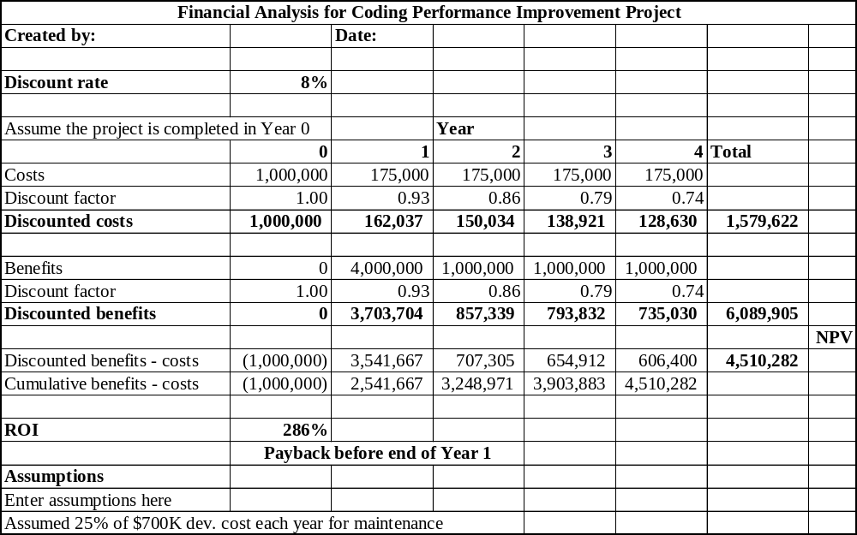
6. Prepare a project charter for the Coding Performance Improvement Project. Assume the project will take six months to complete and cost about $300,000. Use the project charter template provided in Appendix D.
SOLUTION: Below is one possible solution:
Project Charter

Project Title: Coding Performance Improvement Project
Project Start Date: 2/1/05 Projected Finish Date: 8/1/05
Budget Information: $300,000 is the estimated project cost for the Six Sigma project.
Project Manager: PM, PM@gci.com, (667)557-4777
Project Objectives: The main purpose of this project is to improve coding performance at Global Computers, Inc. by following a Six Sigma approach. Increased coding efficiency will result in saving millions of dollars on supercomputer and mainframe computing power.

Approach:
- Select the project team
- Develop and follow a strategy to ensure strong user involvement
- Follow the Six Sigma DMAIC process to improve the coding processes
- Document the results to use them in a follow-on project to implement new coding processes
Roles and Responsibilities
Role | Name | Organization/  Position | Contact Information
Project sponsor | Manager X | GCI, senior manager | managerx@myh.com
Project manager | PM | GCI, manager | tonyprince@myh.com
Project team members | Team members | GCI IT, HR, finance
CIO | Manager Y | Senior manager
CFO | Manager Z | Senior manager

Sign-off: (Signatures of all above stakeholders. Can sign by their names in table above.)

Comments: (Handwritten or typed comments from above stakeholders, if applicable)

Part 2: Planning
Scenario
Congratulations! You have been selected as the project manager for the Coding Performance Improvement Project. The company’s CIO, Mary, is the project sponsor. Now you need to put together your project team and get to work on this high-visibility project. Top management has told you that you can hand pick your team. In addition, you need to attend a 5-day Six Sigma class before you start working on this project, and you will have a senior manager at your company and Six Sigma Master Black Belt, Kevin, acting as your mentor throughout the project. Kevin will also be overseeing your team’s progress.

Tasks
1. Write a one- to two-page paper describing your “dream team” for this project. What type of people would you want on your team? Make up names, backgrounds, and personality traits for your dream team. Assume you are considering having four full-time people and four people working 25 percent of their time on your team.
SOLUTION: Answers will vary. Be sure the team includes/promotes strong user involvement.
2. Develop a team contract for this project using the members of your team defined in step 1 above. Use the template provided in Appendix D as a guide. Look at the examples of project charters in Chapters 3 and 5.
SOLUTION: Answers should resemble the team contract template and examples found in the text.
3. Prepare a stakeholder analysis for this project, using the template provided in Appendix D and example in Chapter 4 as guides. Be creative in making up information about stakeholders.
SOLUTION: Answers will vary but should follow the examples in the text.
4. Develop a scope statement for the project. Use the template provided in Appendix D and the example in Chapter 3 as guides. Be as specific as possible in describing product characteristics, requirements, and deliverables.
SOLUTION: Answers will vary but should follow the example in Chapter 3.
5. Develop a work breakdown structure (WBS) for the project. Break down the work to level 2 or level 3, as appropriate. Use the Six Sigma DMAIC steps described in Chapter 8 of this text as part of your WBS. Include two days of Six Sigma training for all team members as part of your WBS. Use the template in Appendix D and samples in Chapters 3 and 5 as guides. Print the WBS in list form as a Word file. Be sure to base your WBS on the project charter, scope statement, and other relevant information.
SOLUTION: Answers will vary. Below is one possible solution. Note that it uses the project management process groups as the level 1 WBS items, and the DMAIC steps provide the basis for the executing tasks.
1.0 Initiating
1.1 Select project manager
1.2 Form project team
1.3 Develop project charter
2.0 Planning
2.1 Develop user involvement strategy
2.2 Develop scope statement
2.3 Create WBS
2.4 Develop and refine other plans
3.0 Executing
3.1 Define
3.2 Measure
3.3 Analyze
3.4 Improve
3.5 Control
4.0 Controlling
5.0 Closing
5.1 Prepare final report and presentation
5.2 Deliver final report and presentation

6. Use the WBS you developed in step 5 above to create a Gantt chart and network diagram in Project 2002 for the project. Estimate task durations and enter dependencies, as appropriate, and include several milestones. Remember that your schedule goal for the project is six months. Print the Gantt chart and network diagram.
SOLUTION: Answers will vary. Below is one potential solution. You can access the file case2_task2-6.mpp on the Instructor’s CD.
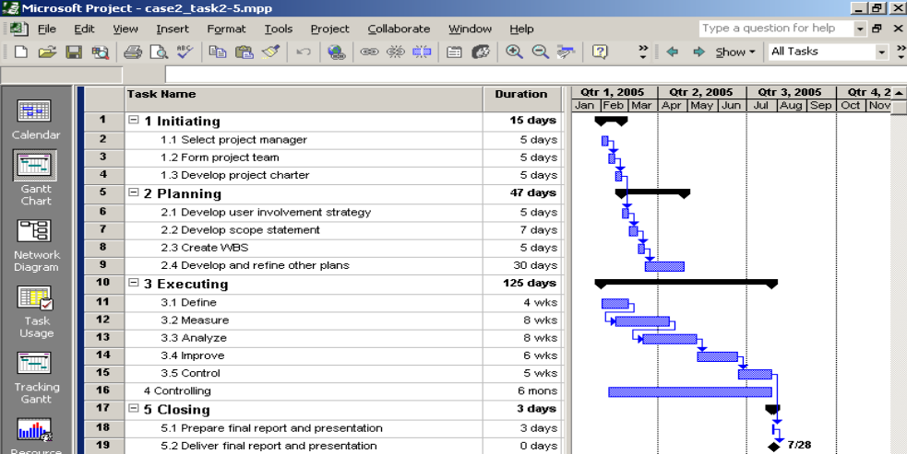
7. Create a spreadsheet to estimate project costs, clearly labeling all information. List each team member’s name, how many hours he or she works each week on average, the hourly labor rate, and the total labor cost per person and for the entire project. Assume the six-month project is 26 weeks. Also, assume that you work an average of thirty hours per week on the project and earn $80 per hour. Assume that Kevin, your mentor, works ten hours per week on the project and earns $120 per hour, and the other team members earn $50 per hour. Assume no one is paid overtime. Include Six Sigma training costs for all full-time team members at $1000 each. Print your spreadsheet with your cost estimate based on this data. Remember that your budget for the six-month project is $300,000. Propose what changes you would make to meet this budget goal.
SOLUTION: Below is a solution. Recall that the project includes 4 full-time team members and 4 team members working 25% of their time on the project. Based on this information, the cost estimate is $357, 600, while the budget is only $300,000. Suggestions to reduce costs would be to lower the number of hours people spend on average per week or perhaps eliminate some team members.
Coding Performance Improvement Project Cost Estimate
Labor costs
Staff Names | Ave. weekly hours | No. weeks | Total hours | Cost/hour | Total cost
PM | 30 | 26 | 780 | $80 | $62,400
Kevin | 10 | 26 | 260 | $120 | $31,200
Member 1 | 40 | 26 | 1040 | $50 | $52,000
Member 2 | 40 | 26 | 1040 | $50 | $52,000
Member 3 | 40 | 26 | 1040 | $50 | $52,000
Member 4 | 40 | 26 | 1040 | $50 | $52,000
Member 5 | 10 | 26 | 260 | $50 | $13,000
Member 6 | 10 | 26 | 260 | $50 | $13,000
Member 7 | 10 | 26 | 260 | $50 | $13,000
Member 8 | 10 | 26 | 260 | $50 | $13,000
Total labor costs |  |  |  |  | $353,600
Training costs |  |  |  |  | $4,000
4 full-time people *$1,000 each
Total cost estimate |  |  |  |  | $357,600

8. Create a probability/impact matrix and list of prioritized risks for the project. Include at least ten risks. Use the templates provided in Appendix D and examples in Chapters 3 and 11.
SOLUTION: Answers will vary. Potential risks might include a lack of management support, lack of user inputs, inexperience in using the DMAIC steps, difficulty analyzing potential solutions, communication problems, schedule problems, personality conflicts, and so on.

Part 3: Executing
Scenario
You and your project team have run into a few challenges in executing the Coding Performance Improvement Project. Three months have passed since the project started. You selected four full-time people for your dream team and four people working quarter time. Unfortunately, you selected full-time team members who were all pretty much like you⎯all drivers and natural leaders. Everyone kept trying to say how to do things, but no one wanted to pay attention to the details and get the actual work done. In addition, no one on your team really understood how Six Sigma projects worked, and the training was not very helpful. No one realized how many process diagrams and how much data you had to collect. No one understood the statistics you had to run as part of the project, and the programmers on your team think all of the paperwork and number crunching is a waste of time. They think all you need to do is hold a few meetings with all of the programmers and have them follow a few basic guidelines to make their code more efficient. Kevin, your mentor and a Master Black Belt, is trying to help out, but he is ready to reassign at least half of the people on your project to his own dream team.

Tasks
1. Research the DMAIC process. Write a two- to three-page paper summarizing the steps involved and how it would apply to this project. Include at least three references, including at least one article from the www.isixsigma.com Web site. Discuss whether or not you think some of the team members have legitimate complaints and why.
SOLUTION: Answers will vary. There are many books, articles, and Web sites with information on the DMAIC process. www.isixsigma.com is a good site to visit.
2. Create a Pareto diagram related to the Coding Performance Improvement Project using the template provided in Appendix D. Assume you have been tracking the common coding inefficiencies programmers make by examining random samples of code from several programs. Assume there are six categories of inefficiencies with the following frequency counts:
- Category 1: 24
- Category 2: 72
- Category 3: 28
- Category 4: 15
- Category 5: 57
- Category 6: 4
SOLUTION: Below is the Pareto diagram and spreadsheet used to create it.
Pareto Diagram for Project Name
Problem | Count | % | Cumulative %
Category 2 | 72 | 36% | 36%
Category 5 | 57 | 29% | 65%
Category 3 | 28 | 14% | 79%
Category 1 | 24 | 12% | 91%
Category 4 | 15 | 8% | 98%
Category 6 | 4 | 2% | 100%
Total | 200
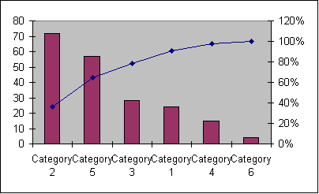

Note: Answers to the rest of the executing tasks will vary. The tasks are provided here for your convenience.
3. Develop a project Web site for the Coding Performance Improvement Project. See the sample template provided in Chapter 10. Include links to all project documents you have created so far, as well the items you prepared for steps 1 and 2 above. Include links to helpful Web sites about Six Sigma. Post the pages on the Internet.
4. Prepare five to ten slides for a short presentation you need to make to the Six Sigma Steering Committee, a group of senior managers in your company, about the status of the project so far. You have been instructed to be very honest in your presentation and raise all important issues. You know that this committee also likes to see suggested solutions to problems.
5. Prepare a milestone report for the project based on information in your Gantt chart. Assume you have completed the first three months of your project. Add additional milestones, if needed, to make the report more meaningful. Use the milestone report template in Appendix D and the sample provided in Chapter 3.
6. Develop an agenda for a project team meeting to work through some of the challenges you are facing in executing the project so far. Write a one- to two-page paper with several alternatives for addressing these challenges.

Part 4: Controlling
Scenario
After the Six Sigma Steering Committee meeting halfway though your project, you have been demoted to team member and Kevin, your mentor, is taking over the role as project manager. Kevin kept all four part-time team members and one of the full-time team members, but he replaced the other three people with his own staff. You had the option to quit the project, but you decided to stay on since you knew much of the history, and you really did want to see how someone else would run things. You respected Kevin’s work so far and wanted to learn more from him. Kevin still plans to finish the project in three more months. He has been given authority to go a bit over budget as long as a new, more conservative financial analysis shows that this project and the following one are good investments.

Tasks
1. Review the Gantt chart you created in part 2. Enter actuals for the first three months, assuming the project was about 20 percent behind schedule and 20 percent over budget. Print the earned value table. Import the data into Excel and create an earned value chart.
SOLUTION: Answers will vary depending on how the Gantt chart was created. The earned value chart should show the cost and schedule problems. It can be very difficult to use Project for cost information, so you might want to suggest that students enter the data in Excel.
2. Update the cost estimate you created in part 2. Assume that for the first 13 weeks of the project, you only used two people working 25 percent of the time for 10 hours each week, you cut your hours to 20 hours per week instead of 30, and you cut Kevin’s hours to 6.5 hours per week instead of 10 hours per week. The four full-time team members did charge 40 hours per week and attended Six Sigma training that cost $1000 for each of them. Create a new spreadsheet showing these actual costs to date. Then provide an estimate of what it will cost to complete the project in the next three months. Assume Kevin works 30 hours per week, you work 30 hours per week, the two part-time people work 20 hours per week, and all of Kevin’s new team members work an average of 120 hours per week total at $100 per hour.
Solution: Below is an updated spreadsheet:
Coding Performance Improvement Project Cost Estimate, Part 4-2
Actual for first 13 weeks
Labor costs | Ave.
Staff Names | Weekly hours | No. weeks | Total hours | Cost/hour | Total cost
You | 20 | 13 | 260 | $80 | $20,800
Kevin | 6.5 | 13 | 84.5 | $120 | $10,140
Member 1 | 40 | 13 | 520 | $50 | $26,000
Member 2 | 40 | 13 | 520 | $50 | $26,000
Member 3 | 40 | 13 | 520 | $50 | $26,000
Member 4 | 40 | 13 | 520 | $50 | $26,000
Member 5 | 10 | 13 | 130 | $50 | $6,500
Member 6 | 10 | 13 | 130 | $50 | $6,500
Member 7 | 10 | 0 | 0 | $50 | $0
Member 8 | 10 | 0 | 0 | $50 | $0
Total labor costs |  |  |  |  | $147,940
Training costs |  |  |  |  | $4,000
4 full-time people *$1,000 each
Total actuals for the first 13 weeks |  |  |  |  | $151,940
Estimate for last 13 weeks
Labor costs | Ave.
Staff Names | Weekly hours | No. weeks | Total hours | Cost/hour | Total cost
You | 30 | 13 | 390 | $80 | $31,200
Kevin | 30 | 13 | 390 | $120 | $46,800
Other members | 120 | 13 | 1560 | $100 | $156,000
Part-time members | 20 | 13 | 260 | $50 | $13,000
Total labor costs for last 13 weeks |  |  |  |  | $247,000
Total project estimate |  |  |  |  | $398,940

3. Create an updated financial analysis for this project. Use the cost estimate you created in step 2 above for the project’s cost, and include the cost of the next nine-month project at $700,000. Assume ongoing costs of $100,000 each year for the following four years. Assume the estimated benefits are $2 million the first year after implementation and $1 million per year for the next two years. Use an 8 percent discount rate. Determine the NPV, ROI, and payback period for both of these projects using this information. Use the financial analysis for business case template in Appendix D or the examples in Chapter 5.
SOLUTION: Below is an updated financial analysis based on this new information:
Financial Analysis for Coding Performance Improvement Project
Created by: |  | Date:
Discount rate | 8%
Assume the project is completed in Year 0 |  |  | Year
 | 0 | 1 | 2 | 3 | 4 | Total
Costs | 1,098,940 | 100,000 | 100,000 | 100,000 | 100,000
Discount factor | 1.00 | 0.93 | 0.86 | 0.79 | 0.74
Discounted costs | 1,098,940 | 92,593 | 85,734 | 79,383 | 73,503 | 1,430,153
Benefits | 0 | 2,000,000 | 1,000,000 | 1,000,000 | -
Discount factor | 1.00 | 0.93 | 0.86 | 0.79 | 0.74
Discounted benefits | 0 | 1,851,852 | 857,339 | 793,832 | - | 3,503,023
 |  |  |  |  |  |  | NPV
Discounted benefits - costs | (1,098,940) | 1,759,259 | 771,605 | 714,449 | (73,503)
  2,072,870
Cumulative benefits - costs | (1,098,940) |  | 1,431,924 | 2,146,373 | 2,072,870
  660,319
 | 145%
  ROI
 | Payback before end of Year 1

4. Kevin has asked you to meet personally with the four project team members that he decided to pull off the project. Write a one- to two-page paper describing what you would say to these members of your former dream team. Be careful to put yourself in their shoes and make the meetings good learning experiences for everyone involved.
SOLUTION: Answers will vary.

Part 5: Closing
Scenario
Kevin did a great job managing the rest of the Coding Performance Improvement Project. You were very impressed with his ability to pull everyone together to meet project goals. Your final project presentation to top management is next week. You did meet your schedule goal, and the final cost for the whole system was about $400,000. Top management is pleased with the results, even though it cost about 25 percent more than planned. They appreciated Kevin’s and your honesty in redoing the financial estimates, which still made the project look like an excellent investment.
Note: All of the closing task solutions will vary. The tasks are provided below for your convenience.

Tasks
1. Kevin asked you to help him prepare and present the final project presentation. Prepare a short presentation with ten to fifteen slides that you would give in a fifteen- to twenty-minute presentation to the Six Sigma Steering Committee.
2. Prepare a lessons-learned report for what you personally learned from this project. Use the template provided in Appendix D, and be creative in your response.
3. Prepare a final project report, using information provided in the template for final project documentation in Appendix D.
4. The Six Sigma Steering Committee asked you to prepare more detailed information on how the financial benefits of this Coding Performance Improvement Project and the follow-up implementation project were determined. They also want you to meet with a senior member of the finance department to help them audit the results each year. Write a one- to two-page report describing how the benefits could be calculated and how they could be automated. Assume that all of the projected savings come from a decrease in the number of mainframe computers and supercomputers the company will need to run since the code is more efficient.
5. Update the project Web site to make sure it includes all final project and product deliverables.

RUNNING Case 3: wedding project
This running case does not directly involve an information technology project, although you will need to use several software applications to complete the running case. These scenarios may be easier for you to relate to, and you can easily change parts of it to a similar scenario, such as planning a large reunion or similar event. This running case also involves using many of the templates provided in this text.

Part 1: Initiating
Scenario
Your best friend, Chelsea, just got engaged, and she’s terrible at planning anything. She is highly emotional, and she relies on you, her down-to-earth, rational friend, in many situations. The couple has asked you to be in their wedding and to help with a lot of the wedding planning. The wedding is next summer, so you have one year to plan everything. Chelsea’s parents gave them a very limited budget for the wedding, $5,000, and her fiancé’s family has agreed to pay for all of the beverages that will be served at the wedding reception. They will also host the rehearsal dinner. Both the bride and groom have many friends and relatives, and their initial estimate is that 200 people would attend. They really want to have a nice wedding, with a full dinner, large bridal parties, a live band, a honeymoon in Hawaii, and so on. Neither Chelsea nor her fiancé, Chris, have much money of their own to contribute to wedding expenses, but they think they can come up with another $5,000 at the most if they have to.

Tasks
1. You know that Chelsea has grand plans for her wedding and you have to help define the scope to meet her budget. Many bridal magazines and Web sites have checklists to help identify everything that needs to be done and bought for a wedding. Research at least three different sources, and then put together a checklist and list of questions you want Chelsea and Chris to answer to help in planning the wedding.
SOLUTION: Answers will vary. There are many Web site with wedding planning information. The site www.wednet.com had a link to the top 100 wedding sites in June 2003. There are also several bridal magazines that include a lot of wedding planning information. The site www.modernbride.com is another good reference and also has a magazine with the same name.
2. Research information about the costs of weddings and determine the major cost drivers. Add some questions to the list you created in step 1 above to help prioritize the most important elements of their wedding and where you might be able to cut costs. You know that Chelsea’s aunt is a great seamstress, and Chris’s mother runs a flower shop.
SOLUTION: Answers will vary. The reception, the honeymoon, rings, dresses, etc. are all usually major cost drivers for wedding expenses. Modern Bride suggests that the reception alone accounts for about half of the cost of most weddings. The location, meal, drinks, number of people attending, music, and so on drive the costs of the reception.
3. Prepare a project charter for Chelsea’s wedding. Assume that Chelsea and Chris are the project sponsors and you are the project manager. The budget is $10,000, and you have no more than twelve months to plan the wedding. Include both sets of parents as key stakeholders on the project charter.
SOLUTION: Answers will vary. See the template for a project charter and examples in the text.

Part 2: Planning
Scenario
After researching several checklists and having many discussions with their parents and you, Chelsea and Chris are beginning to firm up some of the wedding plans. They realize they will have to be extremely budget-conscious, but they think that everyone can enjoy their wedding without spending a fortune. Key cost drivers will be the cost of the meal, the number of people who come for the meal, the cost to rent a hotel function room or hall (or provide tables and chairs if they decide to have the reception at one of their parents’ homes), and the cost for the honeymoon. Chelsea’s aunt has agreed to make her dress and veil as well as the bridesmaids’ gowns, but Chelsea still needs to pay for the materials. Chris’s mom said that her shop would donate all of the flowers, as long as the flowers are not too lavish. Chris has some friends in a small band who have agreed to play at the reception for a very small fee, and the couple decided that they could put off going to Hawaii for a few years. As long as they can spend at least three nights in a nice bed and breakfast by a lake or beach, they will be happy.
Tasks
1. Develop a scope statement for the project. Use the template provided in Appendix D and the example in Chapter 3 as guides. Be as specific as possible in describing product characteristics and requirements as well as deliverables. Be creative, and pretend that you are the bride and groom coming up with these requirements.
SOLUTION: Answers will vary. Be sure the scope statement describes all deliverables in detail.
2. Develop a work breakdown structure (WBS) for the project. Use some of the wedding planning checklists to help decide on the WBS categories. For example, food will be a major category, as will clothing. Break down the work to Level 2 or Level 3, as appropriate. Use the template in Appendix D and samples in Chapters 3 and 5 as guides. Print the WBS in list form as a Word file. Be sure to base your WBS on the project charter, scope statement, and other relevant information.
SOLUTION: Answers will vary. Many Web sites provide checklists to follow with things to do 12 months before the wedding, 6 months before, 3 months before, and so on. Below is one potential WBS:
1.0 Invitations
2.0 Gift registry
3.0 Ceremony
3.1 Book church and priest
3.2 Create programs
3.3 Select and order flowers
4.0 Select and purchase rings
5.0 Reception
5.1 Research locations
5.2 Select location
5.3 Select food
5.4 Select drinks
5.5 Select and order cake
5.6 Select and book music
6.0 Attire
6.1 Bridal gown
6.2 "Veil, shoes, etc."
6.3 Bridesmaids dresses
6.4 Flower girl dress
6.5 Ring bearer
6.6 Groomsmen
6.7 Ushers
6.8 Parents’ attire
7.0 Photography
8.0 Honeymoon plans
9.0 Wedding day

3. Use the WBS you developed in step 2 above to create a Gantt chart and network diagram in Project 2002 for the project. Estimate task durations and enter dependencies, as appropriate, and include several milestones. For example, you know that you have to reserve the church as soon as possible since many of items depend on having a firm date. Chelsea’s aunt would like to have at least four months to make all of the dresses, and an additional month after the fitting to make any adjustments. Print the Gantt chart and network diagram.
SOLUTION: Answers will vary. Note that the WBS from above was modified based on the information about making the dresses. Also note that there appears to be a lot of slack in many of the tasks. This type of project might best be scheduled from the end date of the project instead of the start date, if the end date is known in advance. You can access this file, case3_task2-3.mpp, on the Instructor Resource CD.
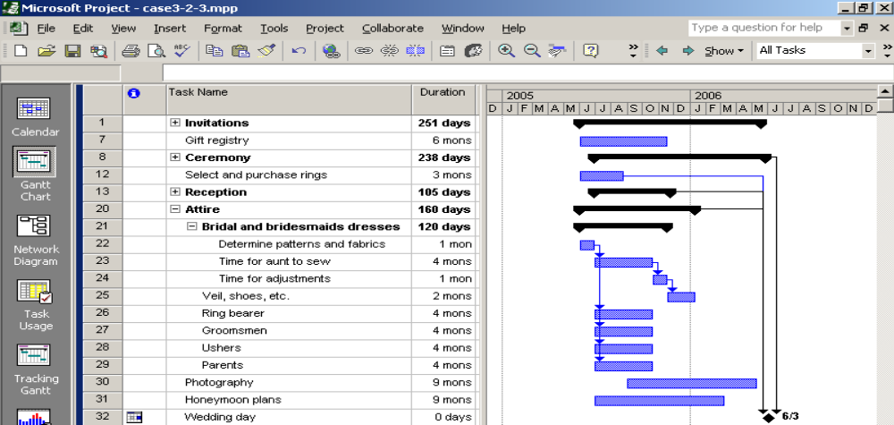
4. Create a spreadsheet to model the costs for the entire wedding and honeymoon. Clearly label all of the items, quantities, assumptions, and so on. Include a notes column to keep track of special notes or comments. Make the input variables very clear, such as number of people attending, number of bridesmaids and groomsmen, number of nights in a hotel for the honeymoon, number of pictures they plan to order, and so on. Enter what you think are realistic numbers and print your results. Write a one- to two-page paper explaining the cost model. If the final estimate is above or below $10,000, describe suggestions for bringing the costs closer to the budget.
SOLUTION: Answers will vary. Below is one potential estimate. Note that some items from the WBS are not included since they do not have costs associated with them for the bride and groom, like the parents’ attire. A few items were also added, like gifts for attendants. Note that this initial estimate totals $10,010. The cost of the meal at the reception is $5,000. If the bride and groom really want to cut costs, they should focus on this item. Perhaps they could invite a few less people or negotiate a lower cost/meal for the reception.

Case 3 Wedding Cost Estimate
Key inputs/variables
# people attending | 200
# invitations sent | 250
cost/invitation | 1
cost/program | 0.5
meal cost/person | 25
# bridesmaids | 5
cost/dress for fabric | 50
# male attendants | 7
cost/tux rental | 60
cost/gift for attendants | 20
# picture sheets ordered | 40
cost/picture sheet | 10
# nights for honeymoon | 3
cost/night for honeymoon (all expenses) | 150
Itemized Costs | Total costs
Invitations | 250
Ceremony (minister, servers, etc.) | 300
Programs | 100
Flowers (free from mom's shop) | 0
Wedding rings | 900
Hall/tent rental | 500
Food at reception | 5000
Cake | 400
Music | 200
Bridal gown | 400
Veil, shoes, etc. | 200
Bridesmaids/flower girl dresses | 250
Tuxes for groom, etc. | 420
Gifts for attendants | 240
Photography | 400
Honeymoon | 450
Total | $ 10,010

5. Create a probability/impact matrix and list of prioritized risks for the wedding. For example, you know that Chris has friends with a band who said they would play for a minimal fee, but if they get a job that pays them more money that night, they might back out. Include at least ten risks in your list. Use the templates provided in Appendix D and examples in Chapters 3 and 11.
SOLUTION: Answers will vary. Potential risks include not having the band available, having way more people than expected plan to attend the reception, having the meal cost be much higher than expected, personality clashes between family and friends, high stress levels, disagreements over selections (i.e. what food and drinks to serve, what fabric to use for dresses, what type of flowers to have, etc.).

Part 3: Executing
Scenario
It is just two weeks before the wedding. Chelsea is trying on her dress, and she looks fabulous. However, you are running into some problems. Chris’s friends with the band just called and said they cannot make it. So, you are scrambling to find another band or possibly a deejay at this late notice. Chelsea’s mom told you in confidence that her flower shop is not doing very well. She knows that Chelsea really wants to have a lot of flowers in the church and orchids in her bouquet, but it would be much cheaper to use flowers that are in season, such as the lilacs that are just starting to bloom. She asked you if you would talk to Chelsea about changing her plans for flowers. You made what you thought were final arrangements with the food caterer and planned to have 200 people, but you are estimating that only 180 guests will attend, at most. You want to see if the caterer will not charge for those twenty people, even though your contract with them was based on serving 200 people.

Tasks
Answers to all of the executing, controlling, and closing tasks will vary. They are provided here for your convenience.
1. Develop a project Web site for Chris and Chelsea’s wedding. See the sample template provided in Chapter 10, but feel free to make it more personal. Include links to all project documents you have created so far. Also, include links to helpful sites about weddings and the couple’s unique interests. Post the pages on the Internet.
2. As part of your surprise wedding gift to Chris and Chelsea, you plan to take digital photos and short videos and put them on their own Web site. You bought them their own domain name, and you have scanned several photos of Chris and Chelsea that you got from their parents. Develop a prototype of this Web site using some of your own personal photos. Post the pages on the Internet. Include a page that explains how you purchased the domain name, how you scanned in photos, how you created short videos that run on the Web, and how you created the site. Consider using a tool such as FrontPage or Dreamweaver to create the site.
3. Chris and Chelsea’s parents really appreciate all the help you have given their children in planning their wedding. They want to know how well you are meeting the budget goals for the wedding, and they wonder if you would talk to their children about controlling their money once they are married. Write a one- to two-page paper summarizing where you have spent the wedding money so far and projecting future expenditures. Include advice on how to control costs after they are married, too. Assume that Chris and Chelsea will need to spend $5,000 of their own money. Their parents know they only had $3,000 and will need a loan for the rest of the money. They also know that their children have credit card debt, and they would be better off taking out a different type of loan. Include a sheet in your spreadsheet called loans to help the couple figure out what their payments will be for a loan with varying interest rates and terms.
4. Chelsea’s older sister, Alexis, has not been very cooperative throughout the wedding planning process. She just burst into the room and told Chelsea how much she hated the bridesmaid dress she had to wear and told her she is crazy to get married to the first guy she fell for. Alexis vowed not to get married until she is over thirty, and Chelsea is only twenty-three. Chelsea started to cry, and you know you have to say something. Write a short paper describing what you might say at that instant and how you can help Chelsea to deal with her older, very opinionated sister in the future.

Part 4: Controlling
Scenario
The wedding ceremony was beautiful, and people are just lining up outside the reception hall to greet the bride and groom when they come in. You thought you could just enjoy the wedding day, especially after you worked so hard to plan everything just right. Well, the caterer recognizes you from a prior meeting, and tells you there are only enough of the china serving plates for 150 people instead of 180 because someone misread the contract. There are some paper plates in the kitchen. Can they use those? The photographer just realized that he forgot to bring his flash. He asks you if someone can take pictures outside for him for about thirty minutes while he runs home to get it. You hear the band warming up in the background, and they sound awful! You suddenly awaken from your dream and realize you still have one more week before the wedding.
Tasks
1. Instead of making yourself available to take care of last-minute problems on the day of the wedding, you decide to do a little more verification work this week and develop contingency plans. You also plan to ask your sister, who is also very organized and level-headed, to take over for you on the day of the wedding. Write a one- to two-page paper describing important items you want to verify before the wedding day and describing some contingency plans to have in place to avoid any problems.
2. Create a checklist for all of the items you want to verify this week. Include extra items you might keep in your sister’s car trunk, such as plates, a good camera, and so on.
3. Update the project charter, scope statement, and Gantt chart to reflect what actually happened with the project planning and execution. Set a baseline on your Gantt chart, and then enter actual schedule information. Assume that some things took longer than planned (like deciding on the location and menu), while others took less time (like getting the dresses made and finalizing the honeymoon plans). Print a tracking Gantt chart to show the results.
4. Update your list of prioritized risks. Write a one- to two-page paper explaining the new risk information.

Part 5: Closing
Scenario
Chelsea and Chris just returned from their honeymoon. They had a wonderful time, and they keep thanking you for all of the help you provided. They love the Web site you made for them, and they are even meeting with someone to talk about a new loan, as you suggested. Chris also announced that his older brother just got engaged, and he wondered if you would be willing to share some advice and maybe think about being a paid wedding planner for their wedding. Chelsea’s mom also mentioned that some of her customers at the flower shop have asked her if she could refer any wedding planners and if you would be interested in preparing a business card she could hand out.

Tasks
1. Prepare a short presentation with ten to fifteen slides that you could use as a final project presentation. Assume that you have fifteen to twenty minutes to give the presentation.
2. Prepare a lessons-learned report for the entire wedding project. Include input from all stakeholders in summarizing the lessons learned. Use the template provided in Appendix D, and be creative in your response.
3. Prepare a final project report, using information provided in the template for final project documentation in Appendix D.
4. You did enjoy planning Chelsea and Chris’s wedding. Research the possibility of working part-time as a wedding planner. Estimate how much you would charge for your services and how much work you think you could handle while keeping your full-time job.
5. Update the project Web site to make sure it includes all final project and product deliverables.

RUNNING Case 4: real group project
This running case assumes that you will work in groups and complete a real project for a real project sponsor. It uses several of the templates provided in Appendix D.

Answers to all of these tasks will vary. The tasks are listed here for your convenience.
Part 1: Initiating
Scenario
It is important to initiate projects that add value to an organization. It is also important to follow good project management practices by officially recognizing projects with project charters, assigning competent project managers and other team members, and preparing business cases, if appropriate.

Tasks
1. Based on your experience and personal contacts, propose a potential project that you could work on as part of a team. Complete the Potential Project Proposal Form Template found in Appendix D. The instructor or a student should summarize each of the proposed projects in a simple spreadsheet. List the name of the student who proposed the project, the project name, and the project sponsor, as a minimum
2. Write a one- to two-page paper proposing how to select projects and groups.
3. After projects and groups have been selected, each group should select a project manager. Write a one-page paper (one per group) describing how you decided who would be the project manager. Discuss the key roles of other group members, referring to the project proposal for more information.
4. If applicable, prepare a business case for your group project. Assume the project will last the entire class term, and the only costs will be the number of hours your group puts into the project. Use the business case template provided in Appendix D.
5. Prepare a project charter for your group project. Be sure that your sponsor and all group members sign it. Send out a draft before requesting signatures. Use the project charter template provided in Appendix D.

Part 2: Planning
Scenario
Your project team should communicate with each other, your sponsor, and other key stakeholders to develop the following plans. If you can meet in person, it is often helpful. If the project is virtual, be as clear as possible in your communications.

Tasks
1. Develop a team contract for your project. Use the template provided in Appendix D as a guide. Refer to the examples of project charters in Chapters 3 and 5.
- Prepare a stakeholder analysis for your project, using the template provided in Appendix D and the example in Chapter 4 as guides. Be creative in making up information about stakeholders.
3. Prepare a communications management plan to address how your team will communicate with each other and key stakeholders on this project. Review Chapter 10 for information on this topic.
4. Develop a scope statement for the project. Use the template provided in Appendix D and the example in Chapter 3 as guides. Be as specific as possible in describing product characteristics, requirements, and deliverables.
5. Develop a work breakdown structure (WBS) for the project. Break down the work to level 2 or level 3, as appropriate. Use the template in Appendix D and samples in Chapters 3 and 5 as guides. Print the WBS in list form as a Word file. Be sure to base your WBS on the project charter, scope statement, and other relevant information.
6. Use the WBS you developed in step 4 above to create a Gantt chart and network diagram in Project 2002 for the project. Estimate task durations and enter dependencies, as appropriate. Include several milestones, such as dates for presenting status reports and giving your final project presentation. Print the Gantt chart and network diagram.
7. Assign resources to the tasks in your Gantt chart using Project 2002. See Appendix A for instructions on setting up a resource sheet and assigning resources. Decide as a team how many hours each person would be expected to work on the project in total and roughly how many hours each person might work each week. To simplify, enter a labor rate of $10 for each team member. If there are any fixed costs, enter them also.
8. Create a probability/impact matrix and list of prioritized risks for the project. Include at least ten risks. Use the templates provided in Appendix D and examples in Chapters 3 and 11.

Part 3: Executing
Scenario
Every project will have different challenges during execution. Each project should also have some real product-related deliverables, such as creating a Web site, developing and administering a survey, preparing a research study, and so on.

Tasks
1. Develop a project Web site for your project. Use the sample template provided in Chapter 10, if desired. Include links to all project documents and the products created as part of the project, if possible. Also include information on each team member to personalize the site. Post the pages on the Internet.
2. Create the products you described in your scope statement. Send a note to your instructor and sponsor when key products are completed. If possible, create links to those products on your project Web site. For example, if you create a survey, include a link to the survey.
3. Prepare a milestone report for your project based on information in your Gantt chart. Assume you are halfway through your term, but your project sponsor and instructor are not sure if you are getting much work accomplished. Add additional milestones, if needed, to make the report more meaningful. See Appendix D for a milestone report template and the sample provided in Chapter 3.
4. Develop an agenda for a project team meeting to work through some of the challenges you are facing in executing the project so far. Write a one- to two-page paper with several alternatives for addressing these challenges.

Part 4: Controlling
Scenario
Your instructor and sponsor should let you know what their expectations are for overseeing your project. Each group’s project manager may also have different expectations. You should have included controlling-related items in your WBS and Gantt chart. If not, go back, add them, and complete the steps below.

Tasks
1. Prepare an initial progress report and presentation. Use your project Web site when giving the presentation. Review of all of your planning documents and a summary progress report form similar to the one shown in Appendix D. Be sure to list any issues you have already had or foresee with the project.
2. Prepare at least one more progress report and presentation later in the term. Follow the format used in step 1 above. Show the results of the work you have completed for each presentation. For example, if you are building a Web site for a real project sponsor, show the progress on the Web site during the progress presentations.
3. Review the Gantt chart you created in part 2, and save it as a baseline. Enter the actual start and end dates for each task as it is completed. Enter actual hours and costs, if applicable. Print a tracking Gantt chart at least twice during the term of your project, once about halfway through the project and once at the end of the project.
4. Update the project charter and scope statement as needed. Update your list of prioritized risks and any other plans that need to be updated based on the actual project’s execution. Include a summary of these updates in your progress reports and post them on your project Web site.

Part 5: Closing
Scenario
Use each project’s closing as a learning experience for each student, group, and the entire class.

Tasks:
1. Prepare a twenty- to thirty-minute final presentation for your project. Be as professional as possible in your presentation, and be sure it is a group effort. Show your final project Web site as part of the presentation, and include a link to this final presentation on the Web site.
2. Prepare a lessons-learned report describing what you personally learned by doing the group project. Include lessons learned by classmates if they affected you, too. Use the template provided in Appendix D, and be honest in your response.
3. Prepare a final project notebook, including a final project report, using information provided in the template for final project documentation in Appendix D. Submit the notebook to your instructor and your project sponsor. Include copies of all deliverables. Be sure to have the project name, team member names, project Web site URL, and a date on the front page. Include a table of contents and clearly number or label each part of the report.
4. Update the project Web site to make sure it includes all final project and product deliverables.

